VYSYA COLLEGE, SALEM-103.

NAME : A. KAJA MOHIDEEN | CLASS : I M.Sc. CS
SUBJECT : THEORY OF AUTOMATA | UNITS : 5

AUGUST | SEPTEMBER | OCTOBER
From : 11/08/08  To : 14/08/08  UNIT – I  Automata Theory  - Introduction  - Structural representation  - Automata and complexity  - Alphabets  - Strings  - Languages  - Problems  From : 18/08/08  To : 31/08/08  UNIT – I (Cont..)  Finite Automata  - Introduction  - Deterministic finite automata  - Non-deterministic finite automata  Application  - Text search  - Finite automata with Epsilon transition  ( PPT ) | From : 02/09/08  To : 19/09/08  UNIT – II  Regular Expressions  - Finite automata and regular expression  - Applications of regular expressions  - Algebraic laws of regular expressions  - Proving languages not to be regular  - Decision properties of regular languages  - Equivalence and minimization of automata  - Moore and Mealy machines  ( PPT )  From : 22/09/08  To : 30/09/08  UNIT – III  Context Free Grammar  - Definition  - Derivations using a grammar  - Leftmost and rightmost derivation  - The language of a grammar  - Sentential forms  - Parse trees  Push down automata  - Definition  - Languages of a PDA  - Equivalence of PDAs and CFGs  - Deterministic PDA  ( PPT) | From : 03/10/08  To : 07/10/08  UNIT – IV  Turing Machine  - Introduction  - Notations  - Descriptions  - Transition diagrams  - Languages  - Turing machines and halting.  From : 10/10/08  To : 17/10/08  UNIT – IV (Cont..)  - Programming techniques of Turing machines  - Multitape Turing machines  - Restricted Turing machines  - Turing machines and computers  ( PPT )  From : 20/10/08  To : 31/10/08  UNIT – V  Intractable Problems  - The classes P and NP  - The NP complete problem  - Complements of languages in NP  - Problem solvable in polynomial space  ( PPT )

U N I T - I

What is the purpose of studying automata theory? (or) (5 marks)
What is the need to study Automata theory?

Automata theory is the study of abstract computing devices. There are several reasons why the study of automata and complexity is an important part of the core of computer science.

Introduction to Finite Automata

Finite automata are a useful model for many important kinds of hardware and software. Let us list some of the most important kinds:
- Software for designing and checking the behavior of digital circuits.
- The “lexical analyzer” of a typical compiler, that is, the compiler component that breaks the input text into logical units, such as identifiers, keywords and punctuations.
- Software for scanning large bodies of text, such as collections of web pages, to find occurrences of words, phrases, or other patterns.
- Software for verifying systems of all types that have a finite number of distinct states, such as communications protocols or protocols for secure exchange of information.

There are many systems or components, contains finite number of “states”. The purpose of a state is to remember the relevant portion of the system’s history. The advantage of having only a finite number of states is that we can implement the system with a fixed set of resources.

Example

The simplest finite automaton is an on/off switch. The device remembers whether it is the “on” state or the “off” state, and it allows the user to press a button whose effect is different, depending on the state of the switch. That is, if the switch is in the off state, then pressing the button changes it to the on state, and if the switch is in the on state, then pressing the same button turns it to the off state.
off
on
push
push
start

Fig: A finite automaton modeling an on/off switch

As for all finite automata, the states are represented by circles; in this example, we have named the states on and off. Arcs between states are labeled by “inputs”, which represent external influences on the system. Here, both arcs are labeled by the input Push, which represents a user pushing the button. The intent of the two arcs is that whichever state the system is in, when the push input is received it goes to the other state. the state in which the system is placed initially is called as the “start state”,. In our example, the start state is off, and we conveniently indicate the start state by the word Start and an arrow leading to that state.

Structural Representations:
There are two important notations that are not automaton-like, but play an important role in the study of automata and their applications.

Grammars
- These are useful models when designing software that processes data with a recursive structure.
- The best known example is a “parser”, the component of a compiler that deals with the recursively nested features of the typical programming language, such as expressions-arithmetic, conditional and so on.
- For instance, a grammatical rule like E ⇒ E + E states that an expression can be formed by taking any two expressions and connecting them by a plus sign; this rule is typical of how expressions of real programming languages are formed.

Regular Expressions
These also denote the structure of data, especially text strings. The style of these expressions differ significantly from that of grammars. The UNIX-style regular expression ‘[A-Z] [a-z] * [] [A-Z] [A-Z]’ represents capitalized words followed by a space and two capital letters. This expression represents patterns in text that could be a city and state, e.g., Ithaca NY. It misses multiword city names, such as Palo alto CA, which could be captured by the more complex expression
‘([A-Z] [a-z] * [] [A-Z] [A-Z])’
when interpreting such expressions, we only need to know that [A-Z] represents a range of characters from capital “A” to capital “Z” and [] is used to represent the blank character alone. Also, the symbol * represents “any number of” the preceding expression. Parentheses are used to group components of the expression; they do not represent characters of the text described.

Automata and complexity
Automata are essential for the study of the limits of computation. There are two important issues:
- What can a computer do at all? This study is called “decidability”, and the problems that can be solved by computer are called “decidable”.
- What can a computer do efficiently? This study is called “intractability”, and the problems that can be solved by a computer using no more time than some slowly growing function of the size of the input are called “tactable”.

Give the central concepts of Automata theory. (or)
Explain briefly about Alphabets, Strings, Languages and Problems. (10 Marks)

The most important definitions include the “alphabet” (a set of finite symbols), “strings”(a list of symbols from an alphabet) and “language” ( a set of strings from the same alphabet).

Alphabets
An alphabet is a finite, nonempty set of symbols. We use the symbol ∑ for an alphabet. Common alphabets include:
- ∑ = {0, 1}, the binary alphabet
- ∑ = { a, b, ………..,z}, the set of all lower-case letters.
- The set of all ASCII characters, or the set of all printable ASCII characters.

Strings
A string (or sometimes word) is a finite sequence of symbols chosen from some alphabet. For eg., 01101 is a string from the binary alphabet ∑ = {0, 1}. The string 111 is another string chosen from this alphabet.

The Empty String
The empty string is the string with zero occurrences of symbols. This string, denoted ε, is a string that may be chosen from any alphabet whatsoever.

Length of a String
It is often useful to classify strings by their length, that is, the number of positions for symbols in the string. For instance, 01101 has length 5. The standard notation for the length of a string w is | w |.
For eg., | 011 | = 3 and | ε | =0.

Powers of an Alphabet
If ∑ is an alphabet, the set of all strings of a certain length from that alphabet is expressed by using an exponential notation. We define ∑^{k} to be the set of strings of length k, each of whose symbols is in ∑.

Eg: Note that ∑⁰ ={ε}, regardless of what alphabet ∑ is. That is, ε is the only string whose length is 0.
If ∑ = {0, 1},
then ∑¹ = {0, 1},
∑² = {00,01,10,11},
∑³ = { 000, 001,010,011,100,101,110,111} …..
There is a slight confusion between ∑ and ∑¹. The former is an alphabet; its members 0 and 1 are symbols. The latter is a set of strings; its members are the strings 0 and 1, each of which is of length 1.

- The set of all strings over an alphabet Σ is denoted by Σ*.
- For instance, {0, 1}* = {ε, 0, 1, 00, 01, 10, 11, 000, …. }.
- That is Σ* = Σ⁰ ∪ Σ¹∪ Σ² ∪ . . .
- The set of nonempty strings from alphabet ∑ is denoted by ∑⁺.
- Thus the equivalences are
  - ∑⁺ = ∑¹ ∪ ∑² ∪ ∑³ ∪ ….
  - ∑* = ∑⁺ ∪ {ε}

Concatenation of strings
Let x and y be strings. Then xy denote the concatenation of x and y, that is, the string formed by making a copy of x and following it by a copy of y. If x is the string composed of i symbols
x = a₁a_{2………….}a_{i}
and y is the string composed of j symbols
y = b₁b_{2………….}b_{j},
then xy is the string of length i+j;
xy = a₁a₂…….a_{i}b₁b₂…….b_{j}.
Eg: Let x = 01101 and y = 110. Then xy =01101110 and yx = 11001101.
For any string w, the equations εw = wε = w

Languages
- A set of strings chosen from some ∑*, is called a language, denoted by L.
- The language can be expressed as L ⊆ ∑*.
- For any programming language, the legal programs are a subset of the possible strings that can be formed from the alphabet of the language. This alphabet is a subset of the ASCII characters.
- For example consider the following languages:
  - The language of all strings consisting of n 0’s followed by n 1’s, for some n ≥ 0;
{ε, 01,0011,000111,………}.
  - The set of strings of 0’s and 1’s with an equal number of each:
{ε, 01, 10, 0011, 0101, 1001,…….}
  - The set of binary numbers whose value is a prime: {10, 11, 101, 111, 1011, ……….}
  - ∑* is a language for any alphabet ∑.
  - φ, the empty language, is a language over any alphabet.
  - {ε}, the language consisting of only the empty string, is also a language over any alphabet. Notice that φ = {ε}; the former has no strings and the latter has one string.
Problems

In automata theory, a problem is the question of deciding whether a given string is a member of some particular language. A “problem” can be expressed as a membership in a language. If ∑ is an alphabet, and L is a language over ∑, then the problem L is:
- Given a string w in ∑*, decide whether or not w is in L.
- Eg: The problem of testing can be expressed by the language L_{p} consisting of all binary strings whose value as a binary number is a prime. That is, given a string of 0’s and 1’s say “yes” if the string is the binary representation of a prime and say “no” if not.
- One potentially unsatisfactory aspect of our definition of “problem” is that one commonly thinks of problems not as decision questions but as requests to compute or transform some input. The technique of showing one problem hard by using its supposed efficient algorithm to solve efficiently another problem that is already known to be hard is called a “reduction” of the second problem to the first.

Explain in detail about Deterministic Finite Automata. (or)
Discuss about Deterministic Finite Automata. (10 marks)

The term “deterministic” refers to the fact that on each input there is one and only one state to which the automaton can transition from its current state. A deterministic finite automaton consists of:
- A finite set of states, often denoted Q.
- A finite set of input symbols, often denoted ∑.
- A transition function that takes as arguments a state and an input symbol and returns a state.
- A start state, one of the states in Q.
- A set of final or accepting states F. The set F is a subset of Q.

A Deterministic Finite Automaton will often be referred to by its acronym: DFA. DFA in “five-tuple” notation is given as,
A = ( Q, ∑, δ, q_{o}, F)
Where A is the name of the DFA, Q is its set of states, ∑ is its input symbols, δ its transition function, q_{o} its start state, and F its set of accepting states.

Language of the DFA

- The “language” of the DFA is the set of all strings that the DFA accepts.
- Suppose a₁,a_{2…………} a_{n} is a sequence of input symbols. We start out with the DFA in its start state, q_{o}.
- The transition function δ, say δ(q_{o}, a₁) = q₁ to find the state that the DFA enters after processing the first input symbol a₁.
- Then process the next input symbol a₂, by evaluating δ(q₁, a₂); continue in this manner, finding states q₃,q_{4……..} q_{n} such that δ(q_{i-1}, a_{i}) = q_{i} for each i.
- If q_{n} is a member of F, then the input a₁,a_{2…………} a_{n} is accepted, and if not then it is “rejected”.

Example:
Let us formally specify a DFA that accepts all and only the strings of 0’s and 1’s that have the sequence 01 somewhere in the string. We can write this language as:

L = {w / w is of the form x01y for some strings x and y consisting of 0’s and 1’s only }

Another equivalent description, using parameters x and y to the left of the vertical bar, is:

{x01y/x are any strings 0’s and 1’s}

Examples of strings in the language include 01, 11010, and 100011. Examples of strings not in the language include ε, 0 and 111000.
Simpler Notations for DFA’s
Specifying a DFA as a five-tuple with a detailed description of the δ transition function is both tedious and hard to read. There are two preferred notations for describing automata:
- A transition diagram which is a graph
- A transition table, which is a tabular listing of the δ functions, which by implication tell us the set of states and the input alphabet.

Transition Diagrams:
A transition diagram for a DFA A = (Q, ∑, δ, q₀, F) is a graph defined as follows:
- For each state in Q there is a node
- For each state q in Q and each input symbol a in ∑, let δ(q, a) = p. then the transition diagram has an arc from node q to node p, labeled a. If there are several input symbols that cause transitions from q to p, then the transition diagram can have one arc, labeled by the list of these symbols.
- There is an arrow into the start state q_{o}, labeled start. This arrow does not originate at any node.
- Nodes corresponding to accepting states are marked by a double circle. States not in F have a single circle.
Example
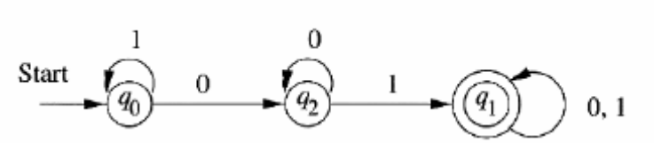
In the figure., given below the three nodes that corresponds to the three states. There is a start arrow entering the start state, q_{o}, and the one accepting state, q₁, is represented by a double circle. Out of each state is one arc labeled 0 and one arc labeled 1.
The transition diagram for the DFA accepting all strings with a substring 01

Transition tables
A transition table is a conventional, tabular representation of a function like δ that takes two arguments and returns a value. The rows of the table correspond to the states, and the columns correspond to the inputs. The entry for the row corresponding to state q and the column corresponding to input a is the state δ(q, a).

Example
The two features of a transition table marked below with the start state being marked with an arrow, and the accepting states are marked with a star. Since we can deduce the sets of states and input symbols by looking at the row and column heads, we can now read from the transition table all the information we need to specify the finite automaton uniquely.
 | 0 | 1
→ q₀ | q₂ | q₀
* q₁ | q₁ | q₁
q₂ | q₂ | q₁

Extending the transition function to strings:

In terms of the transition diagram, the language of a DFA is the set of labels along all the paths that lead from the start state to any accepting state.

We define an extended transition function that describes what happens when we start in any state and follow any sequence of inputs. If δ is our transition function, then the extended transition function constructed from δ will be δ.The extended transition function is a function that takes a state q and a string w and returns a state p – the state that the automaton reaches when starting in state q and processing the sequence of inputs w. We define δ by induction on the length of the input string, as follows:

BASIS δ(q, ε) = q. That is, if we are in state q and read no inputs, then we are still in state q.
INDUCTION Suppose ω is a string of the form xa; that is, a is the last symbol of w, and x is the string consisting of all but the last symbol. For eg., w = 1101 is broken into x = 110 and a =1. Then δ(q, w) = δ(δ(q, x), a)
To compute δ(q,w), first compute δ(q, x), the state that the automaton is in after processing all but the last symbol of w. Suppose this state is p; that is δ(q, x) = p. Then δ(q, w) is what we get by making a transition from state p on input a, the last symbol of ω.That is, δ(q, w) = δ(p, a)

Language of a DFA:
We can define the language of a DFA A =(Q, Σ, δ,q₀, F). This language is denoted L(A), and is defined by
L(A) = { w/δ(q₀, w) is in F}
That is, the language of A is the set of strings w that take the start state q₀ to one of the accepting states. If L is L(A)b for some DFA A, then we say L is a regular language.

Design a DFA to accept the language
L = { w / w has both an even number of 0’s and an even number of 1’s} (or) Give the Deterministic Finite Automata for the Language
L = { w/w has both an even number of 0’s and an even number of 1’s} (5 marks)

The state of the DFA is to count both the number of 0’s and the number of 1’s, but count then modulo 2. That is, the state is used to remember whether the number of 0’s seen so far is even or odd, and also to remember whether the number of 1’s seen so far is even or odd. There are thus four states, which can be given the following interpretations:
q₀ : Both the number of 0’s seen so far and the number of 1’s seen so far are even.
q₁ : The number of 0’s seen so far is even, but the number of 1’s seen so far is odd.
q₂ : The number of 1’s seen so far is even, but the number of 0’s seen so far is odd.
q₃ : Both the number of 0’s seen so far and the number of 1’s seen so far are odd.

State q₀ is both the start state and the lone accepting state. It is the start state, because before reading any inputs, the numbers of 0’s and 1’s seen so far are both zero, and zero is even. It is the only accepting state, because it describes exactly the condition for a sequence of 0’s and 1’s to be in language L. We now know almost how to specify the DFA for language L. It is
A = ({ q₀, q_{1,} q_{2,} q₃}, {0,1}, δ, q₀, {q₀}) where the transition function δ is described by the transition diagram
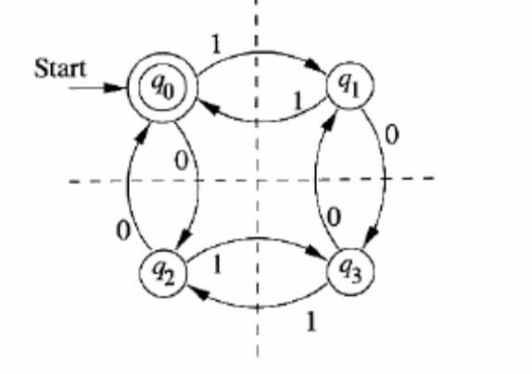
Each input 0 causes the state to cross the horizontal, dashed line. Thus, after seeing an even number of 0’s we are always above the line, in state q₀ or q₁ while after seeing an odd number of 0’s we are always below the line, in state q₂ or q₃. Likewise, every 1 causes the state to cross the vertical, dashed line. Thus, after seeing an even number of 1’s, we are always to the left, in state q₀ or q₁ while after seeing an odd number of 0’s we are always below the line, in state q₂ or q₃. Likewise, every 1 causes the state to cross the vertical, dashed line. Thus, after seeing an even number of 1’s, we are always to the left, in state q₀ or q₂, while after seeing an odd number of 1’s we are to the right, in state q₁ or q₃.
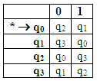
We can also represent this DFA by a transition table.

Here, we illustrate the construction of δ.Suppose the input is 110101. Since this string has even number of 0’s and 1’s both, we expect it is in the language. Thus, we expect δ(q₀, 110101) = q₀, since q₀ is the only accepting state. The check involves computing δ(q₀, w) for each prefix w of 110101, starting at ε and going in increasing size. The summary of this calculation is:
- δ(q₀, ε) = q₀
- δ(q₀, 1) = q₀ = δ(δ(q₀, ε),1) = δ(q₀,1) = q₁
- δ(q₀, 11) = δ(δ(q₀, 1),1) = δ(q₁,1) = q₀
- δ(q₀, 110) = δ(δ(q₀, 11),0) = δ(q₀,0) = q₂
- δ(q₀, 1101) = δ(δ(q₀, 110),1) = δ(q₂,1) = q₃
- δ(q₀, 11010) = δ(δ(q₀, 1101),0) = δ(q₃,0) = q₁
- δ(q₀, 1) = q₀ = δ(δ(q₀, 11010),1) = δ(q₁,1) = q₀

Explain about Non-deterministic Finite Automata. (or) (10 marks)
Discuss in detail about NFA?

A non-deterministic finite automaton (NFA) has the power to be in several states at once. This ability is often expressed as an ability to “guess” something about its input. For instance, when the automaton is used to search for certain sequences of characters(eg., keywords) in a long text string, it is helpful to “guess” that we are at the beginning of one of those strings and use a sequence of states to do nothing but check that the string appears, character by character.

An Informal view of NFA:
Like DFA, NFA has a finite set of states, a finite set of input symbols, one start state and a set of accepting states. It also has a transition function, which we shall commonly call δ. The difference between the DFA and NFA is in the type of δ. For the NFA, δ is a function that takes a state and input symbol as arguments, but returns a set of zero, one or more states.

Example
A non-deterministic finite automaton, whose job is to accept all and only the strings of 0’s and 1’s that end in 01. State q₀ is the start state and we think of the automaton as being in state q₀ whenever it has not yet “guessed” that the final 01 has begun. It is always possible that the next symbol does not begin the final 01, even if that symbol is 0. Thus, state q₀ may transition to itself on both 0 and 1.
q₀
q₀
q₀
Start
0
1
0, 1

Fig(a) An NFA accepting all strings that end in 01

However, if the next symbol is 0, this NFA also guesses that the final 01 has begun. An arc labeled 0 thus leads from q₀ to state q₁. Notice that there are two arcs labeled 0 out of q₀. The NFA has the option of going either to q₀ or to q₁ and in fact it does both. In state q₁, the NFA checks that the next symbol is 1, and if so, it goes to state q₂ and accepts.

Notice that there is no arc out of q₁ labeled 0, and there are no arcs at all out of q₂. In these situations, the thread of the NFA’s existence corresponding to those states simply “dies” although other threads may continue to exist.

The following fig(b) suggests how an NFA processes inputs. We have shown what happens when te automaton of fig(a) receives the input sequence 00101. It starts in only its start state, q₀.When the first 0 is read, the NFA may go to either state q₀ or state q₁, so it does both. These two threads are suggested by the second column in the fig(b),
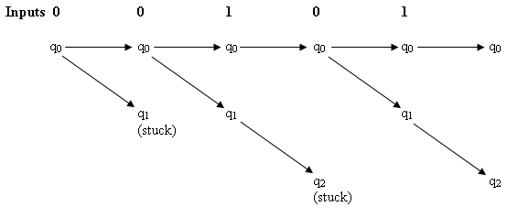
Fig(b) The states of an NFA is in during the processing of input sequence 00101

Then, the second 0 is read. State q₀ may again go to both q₀ and q₁. However, state q₁ has no transition on 0, so it “dies”. When the third input, a1, occurs, we must consider transitions from both q₀ and q₁. We find that q₀ goes only to q₀ on 1, while q₁ goes only to q₂. Thus, after reading 001, the NFA is in states q₀ and q₂. Since q₂ is an accepting state, the NFA accepts 001.However, the input is not finished. The fourth input, a0, causes q₂’s thread to die, while q₀ goes to both q₀ and q₁.The last input, a1, sends q₀ to q₀ and q₁ to q_{2.} Since we are again in an accepting state, 00101 is accepted.

Definition of Nondeterministic Finite Automata:
An NFA is represented essentially like a DFA:
A = (Q, Σ, δ,q_{0,} F)
Where:
- Q is a finite set of states
- Σ is a finite set of input symbols
- q₀ a member of Q, is the start state
- F, a subset of Q, is the set of final (or accepting) states.
- δ, the transition function is a function that takes a state in Q and an input symbol in Σ as arguments and returns a subset of Q.

Example
The NFA of fig(a) can be specified formally as
({ q₀, q_{1,} q_{2,} }, { 0,1}, δ, q₀, { q₂})
where the transition function δ is given by the transition table as follows:
 | 0 | 1
→ q₀ | { q_{0,} q₁ } | { q₀ }
q₁ | φ | { q₂ }
* q₂ | φ | φ
Notice that the transition tables can be used to specify the transition function for an NFA as well as for a DFA. The only difference is that each entry in the table for the NFA is a set, even if the set is a singleton(has one member). When there is no transition at all from a given state on a given input symbol, the proper entry is φ, the empty set.

The Extended Transition Function:
We need to extend the transition function δ of an NFA to a function δ that takes a state q and a string of input symbols ω, and returns the set of states that the NFA is in if it starts in state q and processes the string ω. δ(q, ω) is the column of states found after reading ω, if q is the lone state in the first column. Formally we define δ for an NFA’s transition function δ by:

BASIS δ(q, ε) = {q}. That is, without reading any input symbols, we are in the state we began in.
INDUCTION Suppose w is of the form w = xa, where a is the final symbol of w and x is the rest of w. Also suppose that δ(q, x) = {p₁, p₂, ……. p_{k}}. Let
_{k}
∪ δ(p_{i}, a) = {r₁, r₂,………….r_{m}}
^{i=1}
Then δ(q, w) ={r₁, r₂,………….r_{m}}. Less formally, we compute δ(q,w) by first computing δ(q, x), and by then following any transition from any of these states that is labeled a.

Example
Let us use δ to describe the processing of input 00101 by the NFA of fig(a). A summary of the steps is:
- δ(q₀, ε) = {q₀}
- δ(q₀, 0) = δ(q₀, 0) = { q₀, q₁}
- δ(q₀, 00) = δ(q₀, 0)∪ δ(q_{1,}0) = {q₀, q₁}∪φ={q₀, q₁}
- δ(q₀, 001) = δ(q₀, 1)∪ δ(q_{1,}1) = {q₀}∪{q₂}={q₀, q₂}
- δ(q₀, 0010) = δ(q₀, 0)∪ δ(q_{1,}0) = {q₀, q₁}∪φ={q₀, q₁}
- δ(q₀, 00101) = δ(q₀, 0)∪ δ(q_{1,}1) = {q₀}∪{q₂}={q₀, q₂}
Line(1) is the basis rule. We obtain line(2) by applying δ to the state, q₀, that is in the previous set, and get {q₀, q₁} as a result. Line(3) is obtained by taking the union over the two states in the previous set of what we get when we apply δ to them with input 0. That is, δ(q₀, 0)={q₀, q₁}, while δ(q₀, 0) = φ. For line(4), we take the union of δ(q₀, 1) = {q₀} and δ(q₀, 1) ={q₂}. Lines(5) and (6) are similar to lines(3) and (4).

The Languages of an NFA:
An NFA accepts a string ω if it is possible to make any sequence of choices of next state, while reading the characters of ω, and go from the start state to any accepting state. The fact that other choices using the input symbols of ω lead to a non accepting state, or do not lead to any state at all(i.e., the sequence of states “dies” ), does not prevent ω from being accepted by the NFA as a whole. Formally, if A = ( Q, Σ, δ, q₀, F) is an NFA, then
L(A) = {w/ δ(q₀, w) ∩ F ≠ φ}
That is, L(A) is the set of strings ω in Σ* such that δ(q₀, ω) contains at least one accepting state.

Give a brief note on the equivalence of Deterministic and Non-deterministic Finite Automata? (or)
What do you meant by equivalence? Explain equivalence of DFA and NFA. (10marks)

Every language that can be described by some NFA can also be described by some DFA. The DFA has about as many states as the NFA. Although it often has more transitions. In the worst case, however, the smallest DFA can have 2^{n} states while the smallest NFA for the same language has only n states.

The proof that DFA’s can do whatever NFA’s can do involves an important “construction” called the subset construction because it involves constructing all subsets of the set of states of the NFA.

The subset construction starts from an NFA N =( Q_{N}, Σ, δ_{N}, q₀, F_{N}). Its goal is the description of a DFA D = (Q_{D}, Σ, δ_{D}, {q₀}, F_{D}) such that L(D) = L(N). The input alphabets of the two automata are the same, and the start state of D is the set containing only the start state of N. The other components of D are constructed as follows.
  - Q_{D} is the set of subsets of Q_{N} ; i.e., Q_{D} is the power set of Q_{N}. Note that if Q_{N} has n states, then Q_{D} will have 2^{n} states. Note all these states are accessible from the start state of Q. Inaccessible states can be “thrown away”, so effectively, the number of states of D may much smaller than 2^{n}.
  - F_{D} is the set of subsets S of Q_{N} such that S ∩ F_{N}≠ φ. That is, F_{D} is all sets of N’s states that include at least one accepting state of N.
  - For each set S⊆ Q_{N} and for each input symbol a in Σ,
δ_{D}(S, a) = ∪ δ_{N}(p, a)
^{p in S}
That is, to compute δ_{D}(S, a) we look at all the states p in S, see what states N goes from p on input a, and take the union of all those states.
q₀
q₀
q₀
Start
0
1
0, 1
Example

Let N be the automaton of the above figure that accepts all strings that end in 01. Since N’s set of states is {q₀, q₁,q₂}, the subset construction produces a DFA with 2³ = 8 states, corresponding to all the subsets of these three states. The following figure shows the transition table for these eight states.
This transition table belongs to a deterministic finite automaton. Even though the entries in the table are sets, the states of the constructed DFA are sets. We can invent new names for these states eg., A for φ, B for {q₀} etc., The DFA transition table defines exactly the same automaton but makes clear the point that the entries in the table are single states of the DFA.
 | 0 | 1
φ | φ | φ
→{q₀} | {q₀, q₁} | {q₀}
{q₁} | φ | {q₂}
*{q₂} | φ | φ
{q₀, q₁} | {q₀, q₁} | {q₀, q₂}
*{q₀, q₂} | {q₀, q₁} | {q₀}
*{q₁, q₂} | φ | {q₂}
*{q₀, q₁, q₂} | {q₀, q₁} | {q₀, q₂}
Subset Construction from NFA

 | 0 | 1
A | A | A
→ B | E | B
C | A | D
* D | A | A
E | E | F
* F | E | B
* G | A | D
* H | E | F
Renaming the States

Of the right states in table-2 starting in the start state B, we can only reach states B, E and F. The other five states are inaccessible from the start state. Those states are removed and the table is reconstructed and the DFA diagram is drawn with that table as shown in the figure.
{q₀, q₁}
{q₀, q₂}
{q₀}
Start
0
1
1
0
1
0

Explain how to find string in a text? (or)
Explain the steps involved in finding a string in a text? (10 marks)

A common problem in the age of the web and other on-line text repositories is the following. Given a set of words, find all documents that contain one of those words. The search engine uses a particular technology, called inverted indexes, where for each word appearing on the web a list of all the places where that word occurs is stored. Machines with very large amounts of main memory keep the most common of these lists available, allowing many people to search for documents at once.

Invented-index techniques do not make use of finite automata, but they also take very large amounts of main memory keep the most common of these lists available, allowing many people to search for documents at once. Inverted-index techniques do not make use of finite automata, but they also take very large amounts of time for crawlers to copy the web and set up the indexes. There are a number of related applications that are unsuited for inverted indexes, but are good applications for automaton-based techniques. The characteristics that make an application suitable for searches that use automata are:
- The repository on which the search is conducted is rapidly changing. For eg:
  - Everyday, news analysts want to search the day’s on-line news articles for relevant topics. For eg., a financial analyst might search for certain stock ticker symbols or names of companies.
  - A “shopping robot” wants to search for the current prices charged for the items that its clients request. The robot will retrieve current catalog pages for the web and then search those pages for words that suggest a price for a particular item.
- The documents to be searched cannot be cataloged. For eg., Amazon.com does not make it easy for crawlers to find all the pages for all the books that the company sells. Rather, these pages are generated “on the fly” in response to queries. However, we could send a query for books on a certain topic, say “finite automata”, and then search the pages retrieved for certain words, eg., “excellent” in a review portion.

Construct an NFA for text search? (or)
Give a short note on text search for non deterministic finite automata? (5 marks)

Suppose we are given a set of words, which we shall call the keywords, and we want to find occurrences of any these words. In applications such as these, a useful way to proceed is to design a non-deterministic finite automaton, which signals, by entering an accepting state, that it has seen one of the keyword. The text of a document is fed, one character at a time to this NFA, which then recognizes occurrences of the keywords in this text. There is a simple form to an NFA that recognizes a set of keywords.
- There is a start state with a transition to itself on every input symbol, e.g., every printable ASCII character if we are examining text. Intuitively, the start state represents a “guess” that we have not yet begun to see one of the keywords, even if we have seen some letters of one of these words.
- For each keyword a₁a₂………a_{k}, there are k states, say q₁q₂, ……..q_{k}. There is a transition from the start state to q₁ on symbol a₁, a transition from q₁ to q₂ on symbol a_{2,} and so on. The state q_{k} is an accepting state and indicates that the keyword a₁a_{2……….}a_{k} has been found.

Eg., suppose we want to design an NFA to recognize occurrences of the words web and ebay. The transition diagram for the NFA designed using the rule above is in fig.2.16. State 1 is the start state, and we use Σ to stand for the set of all printable ASCII characters. States 2 through 4 have the job of recognizing web, while states 5 through 8 recognize ebay.
Of course the NFA is not a program. We have two major choices for an implementation of this NFA.
- Write a program that simulates this NFA by computing the set of states it is in after reading each input symbol. The simulation was suggested in fig(b).
- Convert the NFA to an equivalent DFA using the subset construction. Then simulate the DFA directly.
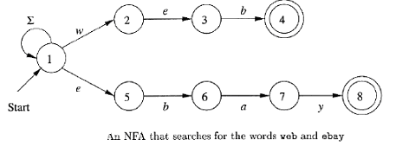

Some text processing programs, such as advanced form of the UNIX grep command(egrep and fgrep) actually use a mixture of these two approaches. However for our purpose conversion to a DFA is easy and is guaranteed not to increase the number of states.

Explain the conversion of NFA to DFA using text search? (or)
Give short notes on conversion of NFA from DFA form of text searches? (5 marks)

When we apply the subset construction to an NFA that was designed from a set of keywords, we find that the number of states of the DFA is never greater than the number of states of the NFA. The rules for constructing the set of NFA states is as follows,
- If q₀ is the start state of the NFA, then {q₀} is one of the states of the DFA.
- Suppose p is one of the NFA states, and it is reached from the start state along a path whose symbols are a₁a₂……..a_{m}. Then one of the DFA states is the set of NFA consisting of:

  - q₀
  - p
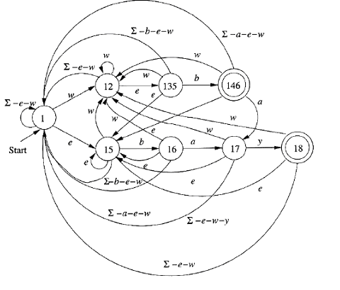
  - Every other state of the NFA that is reachable from q₀ by following a path whose labels are a suffix of a₁a₂…..a_{m}, that is, any sequence of symbols of the form a_{j}a_{j+1}……………..a_{m}.
Fig (c). Conversion of the NFA to a DFA
There will be one DFA state for each NFA state p. However, in step (b), two states may actually yield the same set of NFA states, and thus become one state of the DFA. For eg., if two of the keywords begin with the same letter, say a, then the two NFA states that are reached from q₀ by an arc labeled a will yield the same set of NFA states and thus get merged in the DFA.

Give short notes on Finite Automata with Epsilon Transitions (or)
Explain about Epsilon Transitions on Finite Automata with example? (10 marks)

The new “feature” is that we allow a transition on ε, the empty string. In effect, an NFA is allowed to make a transition spontaneously without receiving an input symbol.

Uses of ε-Transitions:
We shall begin with an informal treatment of ε-NFA’s, using transition diagrams with ε allowed as a label. In the examples to follow, think of the automaton as accepting those sequences of labels along paths from the start state to an accepting state. However, each ε along a path is “invisible”; i.e., it contributes nothing to the string along the path.

Example
The following figure is an ε-NFA that accepts decimal numbers consisting of:
- An optional + or – sign.
- A string of digits.
- A decimal point, and
- Another string of digits. Either this string of digits, or the string(2) can be empty, but at least one of the two strings of digits must be nonempty.
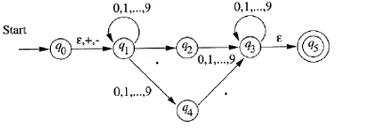
- Of particular interest is the transition from q₀ to q₁ on any of ε, + or -.
- Thus, state q₁ represents the situation in which we have seen the sign if there is one, but none of the digits are decimal point.
- State q₂ represents the situation where we have just seen the decimal point, and may or may not have seen prior digits.
- In q₄ we have definitely seen at least one digit, but not the decimal point.
- Thus, the interpretation of q₃ is that we have seen a decimal point and at least one digit, either before or after the decimal point.

The formal Notation for an ε-NFA:

We may represent an ε-NFA exactly as we do an NFA, with one exception: the transition function must include information about transitions on ε. Formally, we represent an ε-NFA A by A = (Q, Σ, δ, q₀, F), where all components have their same interpretation as for NFA, except that δ is now a function that takes as arguments:
- A state in Q, and
- A member of Σ ∪{ε}, that is, either an input symbol, or the symbol ε. We require that ε, the symbol for the empty string, cannot be a member of the alphabet Σ, so no confusion results.

Example
The above ε-NFA is formally represented as
E =({q₀, q₁, …….q₅}, {., +, - ,0, 1….9}, δ, q_{0 ,} {q₅})
Where δ is defined by the transition table in figure

 | ε | +,- | . | 0,1,…9
q₀ | {q₁} | {q₁} | φ | φ
q₁ | φ | φ | {q₂} | {q_{1,}q₄}
q₂ | φ | φ | φ | {q₃}
q₃ | {q₅} | φ | φ | {q₃}
q₄ | φ | φ | {q₃} | φ
q₅ | φ | φ | φ | φ

Epsilon Closures

ε-closure of a state is defined as finding every state that can be reached from the current state along any path whose arcs are all labeled ε. Formal definition is as follows:

BASIS State q is in ECLOSE(q)
INDUCTION If state p is in ECLOSE(q),and there is a transition from state p to state r lebeled ε, then r is in ECLOSE(q). More precisely, if δ is the transition function of the ε-NFA involved, and p is in ECLOSE(q), then ECLOSE(q) also contains all the states in δ(p, ε).
Example

Consider the following figure; each state is its own ε-closure, with two exceptions
ECLOSE (q₀) = {q₀, q₁}
and ECLOSE (q₃}={q₃, q₅}
The reason is that there are only two ε-transitions, one that adds q₁to ECLOSE(q₀) and the other that adds q₅ to ECLOSE(q₃).

For this collection of states, which may be part of some ε-NFA, we can conclude that
ECLOSE(1) = {1,2,3,4,6}

- Each of these states can be reached from state 1 along a path exclusively labeled ε.
- For eg., state 6 is reached by the path 1→2→3→6. State 7 is not in ECLOSE (1). Since, although it is reachable from state1, the path must use the arc 4→5 that is not labeledε.
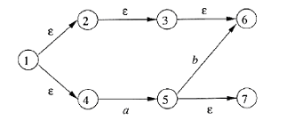
- The fact that state 6 is also reached from state 1 along a path 1→4→5→6 that has non-ε transitions is unimportant.
- The existence of one path with all labels ε is sufficient to show state 6 is in ECLOSE (1).

Write short notes on the extended transitions and languages for ε-NFA’s? (or)
Explain how to extend the transitions and languages for ε-NFA’s (10 marks)

The ε-closure allows us to explain easily what the transitions of an ε-NFA look like when given a sequence of inputs. We can define what it means for an ε-NFA to accept its input.

- Suppose that E=(Q, Σ, δ, q₀, F) is an ε-NFA. We first define δ, the extended transition function, to reflect what happens on a sequence of inputs.
- The intent is that δ(q,w) is the set of states that can be reached along a path whose labels, when concatenated, form the string w.
- ε’s along this path do not contribute to w.

BASIS δ(q,ε) = ECLOSE(q). That is, if the label of the path is ε. Then we can follow only ε-labeled arcs extending from state q; that is exactly what ECLOSE does.
INDUCTION Suppose w is of the form xa, where a is the last symbol of w. Note that a is a member of Σ; it cannot be ε, which is not in Σ. We compute δ(q, w) as follows:

- Let {p₁,p₂,…….p_{k}} be δ(q,x). That is, the p_{i}’s are the states that we can reach from q following a path labeled x. This path may end with transitions labeled ε, and may have other ε-transitions as well.
- Let 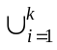 δ( p_{i},a) be the set {r₁,r₂,……….r_{m}}.That is, follow all transitions labeled a from states we can
reach from q along paths labeled x. The r_{j}’s by following ε-labeled arcs in step(3) below.
- Then δ(q,w) = ∪^{k} ECLOSE(r_{j}).This closure step includes all the paths from q labeled w, by considering the possibility that there are additional ε-labeled arcs that can follow after making a transition on the final “real” symbol, a.

Example
Let us compute δ(q₀, 5.6) for the above ε-NFA (page no.13). A summary of the steps needed are as follows:
  - δ( q, ε) = ECLOSE(q₀) = {q₀,q₁}
  - compute δ(q₀, 5) as follows:
    - First compute the transitions on input 5 from the states q₀ and q₁ that we obtained in the calculation of δ(q₀,ε), above. That is, we compute δ(q₀,5) ∪ δ(q₁,5) = {q₁,q₄}
    - Next, ε-closure the members of the set computed in step(1).
    - We get ECLOSE(q₁) ∪ ECLOSE(q₄) = {q₁}∪{q₄} = {q₁,q₄}.That set is δ(q₀, 5). This two-step pattern repeats for the next two symbols.
- Compute δ(q₀, 5.) as follows:
- First compute δ( q₀, .) ∪ δ( q₄, .) = {q₂}∪{q₃} = {q₂,q₃}
- Then compute δ( q₀, 5.) = ECLOSE(q₂) ∪ ECLOSE(q₃) = {q₂}∪{q₃,q₅}= {q₂,q₃,q₅}
- Compute δ( q₀, 5.6) as follows:
  - First compute δ( q₂, 6) ∪ δ( q₃,6) ∪ δ( q₅,6) = {q₃}∪{q₃}∪ φ ={q₃}
  - Then compute δ(q₀, 5.6) = ECLOSE(q₃) = {q₃,q₅}

Explain how to eliminate ε-transitions with an example. (or)
Give a brief note on elimination of ε-transitions? (5 Marks)

Given any ε-NFA, we can find a DFA D that accepts the same language as E. The construction we use is very close to the subset construction, as the states of D are subsets of the states of E. The only difference is that we must incorporate ε-transitions of E, which we do through the mechanism of the ε-closure.
Let E = (Q_{D}, Σ, δ_{E}, q₀, F_{E}). Then the equivalent DFA

D= (Q_{D}, Σ, δ_{D}, q_{D}, F_{D}) is defined as follows:-
- Q_{D} is the set of subsets of Q_{E}. More precisely, we shall find that the only accessible states of D are the ε-closed subsets of Q_{E}, that is, those sets S⊆Q_{E} such that S=ECLOSE(S).
- q_{D} = ECLOSE(q₀); we get the start state of D by closing the set consisting of only the start state of E.
- F_{D} id those sets of states that contain at least one accepting state of E. That is, F_{D}={S/S is in Q_{D} and S∩F_{E} ≠ φ}.
- δ_{D}(S,a) is computed, for all a in Σ and sets S in Q_{D} by:
  - Let S ={ p₁,p₂……p_{k})
  - Compute δ(p_{i}, a); let this set be {r₁,r₂,…..r_{m}}

  - Then δ_{D}(S,a) = 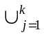 ECLOSE(r_{j})

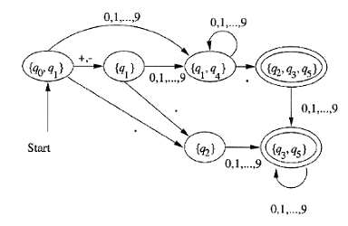
Let us eliminate ε-transitions from the ε-NFA of the above figure, which we shall call E in what follows. From E, we construct an DFA D, which is shown in the following figure. Imagine that for each state shown in fig.2.22 there are additional transitions from any state to φ on any input symbols for which a transition is not indicated. Also, the state φ has transitions to itself on all input symbols 0,1,…..9.

- Since the start state of E is q₀, the start state of D is ECLOSE(q₀), which is {q₀, q₁).
- Our first job is to find the successors of q₀ and q₁ on the various symbols in Σ; note that these symbols are the plus and minus signs, the dot, and the digits 0 through 9.
- On + and -, q₁ goes nowhere in the NFA, while q₀ goes to q₁.
- Thus, to compute δ_{D}({q₀, q₁}, +) we start with {q₁} and ε-close it.
- Since there are no ε-transitions out of q₁, we have δ_{D}({q₀, q₁}, +) = {q₁}. Similarly, δ_{D}({q₀, q₁}, -) = {q₁}. These two transitions are shown by one arc in the figure.
- Next, we need to compute δ_{D}({q₀, q₁}, .). Since q₀ goes nowhere on the dot, and q₁ goes to q₂ in the NFA we must ε-close {q₂}.
- As there are no ε-transitions out of q₂, this state is its own closure, so δ_{D}({q₀, q₁}, .) ={q₂}.
- Finally, e must compute δ_{D}({q₀, q₁}, 0}, as an example of the transitions from {q₀,q₁} on all the digits.
- We find that q₀ goes nowhere on the digits, but q₁ goes nowhere on the digits, but q₁ goes to both q₁ and q₄. Since neither of those states have ε-transitions out, we conclude δ_{D}({q₀, q₁}, 0) ={q_{1,}q₄}and likewise for the other digits.
- Since q₅ is the only accepting state of E, the accepting states of D are those accessible states contains q₅. We see these two sets {q₃, q₅} and {q₂, q₃, q₅} indicated by double circles in figure.

 End of Unit -1 

U N I T - II

Define regular expression with example. (or)
Give a brief note on regular expressions. (10 marks)

The algebraic description of the language is called as “regular expressions”. Regular expressions offer a declarative way to express the strings we want to accept. Thus, regular expressions serve as the input language for many systems that process strings. Examples include:
- Search commands
- Lexical analyzer generators

The operators of Regular Expressions:
Regular expressions denote languages. For a simple example, the regular expression 01* +10* denotes the language consisting of all strings that are either a single 0 followed by any number of 1’s or a single 1 followed by any number of 0’s. Before describing the regular-expression notation, we need to learn the three operations on languages that the operators of regular expressions represent. These operations are:
- The union of two languages L and M, denoted L ∪ M, is the set of strings that are in either L or M, or both. For eg., if L={001,10,111} and M={ε,001}, then L∪M = {ε,10,001,111}.
- The concatenation of languages L and M is the set of strings in L and concatenating it with any string in M. This operator is denoted either with a dot or with no operator at all.
For eg., if L={001,10,111} and M={ε,001}, then
L.M, or just LM is {001,10,111,001001,10001,111001}.
The first three strings in LM are the strings in L concatenated with ε. Since ε is the identity for concatenation, the resulting strings are the same as the strings of L. However, the last three strings in LM are formed by taking each string in L and concatenating it with the second string in M, which is it with the second string in M, which is 001.For instance, 10 from L concatenated with 001 from M gives us 10001 for LM.
- The closure of a language L is denoted L* and represents the set of those strings that can be formed by taking any number of strings from L, possibly with repetitions and concatenating all of them. For instance, if L={0,1}, then L* is all strings of 0’s and 1’s. If L={0,11}, then L* consists of those strings of 0’s and 1’s such that the 1’s come in pairs. e.g., 011,11110 and ε but not 01011 or 101.

Building Regular Expressions:
Algebras of all kinds start with some elementary expressions, usually constants or variables. Algebras then allow us to construct more expressions by applying a certain set of operators to these elementary expressions and to previously constructed expressions. We can describe the regular expressions recursively, as follows. In this definition we not only describe what the legal regular expressions are, but for each regular expression E, we describe the language it represents, which we denote L(E).

BASIS
The basis consists of three parts.
- The constants ε and φ are regular expressions, denoting the languages {ε} and φ respectively. That is, L(ε) = {ε}, and L(φ) = φ
- If ‘a’ is any symbol, then ‘a’ is a regular expression. This expression denotes the language {a}. That is, L(a) ={a}.
- A variable usually capitalized and italic such as L, is a variable, representing any language.

INDUCTION
There are four parts to the inductive step, one for each of the three operators and one for the introduction of parentheses.
- If E and F are regular expressions, then E+F is a regular expression denoting the union of L(E) and L(F). That is, L(E+F) = L(E)∪L(F).
- If E and F are regular expressions then EF is a regular expression denoting the concatenation of L(E) and L(F). That is L(EF) = L(E)L(F).
- If E is a regular expression, then E* is a regular expression, denoting the closure of L(E). That is, L(E*) = (L(E))*.
- If E is a regular expression, then (E), a parenthesized E, is also a regular expression, denoting the same language as E. Formally, L((E))=L(E).

Precedence of Regular-Expression operators:
Like other algebras, the regular expression operators have an assumed order of “precedence” which means that operators are associated with their operands in particular order. For instance, we know that xy+z groups the product xy before the sum, so it is equivalent to the parameterized expression (xy)+z and not to the expression x(y+z). For regular expressions, the following is the order of precedence for the operators.
- The star (closure) operator is of highest precedence.
- Next in precedence comes the concatenation or “dot” operator. After grouping all stars to their operands, we group concatenation operators to their operands. Concatenation is an associative operator, evaluates the expression from the left. For instance, 012 is grouped (01)2.
- Finally, all unions (+ operators) are grouped with their operands. Since union is also associative, it is also evaluates from the left.

Explain finite automata with regular expressions? (or)
Describe finite automata and regular expressions? (10 Marks)

While the regular-expression approach to describe languages is fundamentally different from the finite-automaton approach, these two notations turn out to represent exactly the same set of languages, which we termed the “regular languages”. In order to show that the regular expressions define the same class, we must show that:
- Every language defined by one of these automata is also defined by a regular expression. For this proof, we assume the language is accepted by some DFA.
- Every language defined by a regular expression is defined by one of these automata. For this part of the proof, the easiest is to show that there is an NFA with ε-transitions accepting the same language.

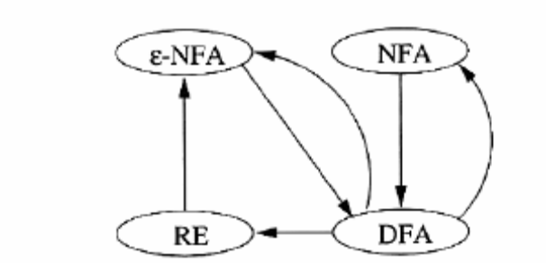

The above figure shows all the equivalences. An arc from class X to class Y means that we prove every language defined by class X is also defined by class Y. Since the graph is strongly connected we see that all four classes are really the same.

From DFA’s to Regular Expressions:
We build expressions that describe sets of strings that label certain paths in the DFA’s transition diagram. However, the paths are allowed to pass through only a limited subset of the states. In an inductive definition of these expressions, we start with the simplest expressions that describe paths that are not allowed to go through any state; i.e., the expressions we generate at the end represent all possible paths.

Example: Let us convert the DFA to a regular expression. This DFA accepts all strings that have at least one 0 in them. To see why, note that the automaton goes from the start state 1 to accepting state 2 as soon as it sees an input 0. The automaton then stays in state 2 on all input sequences.
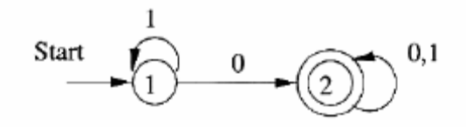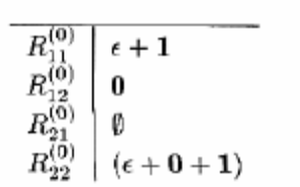
from the DFA, the basis expressions can be constructed as shown in the table.
- For instance, 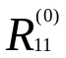 has the term ε because the beginning and ending states are the same, state 1. It has the term 1 because there is an arc from state 1 to state 1 on input 1.
- As another example, 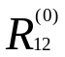 is 0 because there is an arc labeled 0 from state 1 to state 2. There is no ε term because the beginning and ending states are different.
- For a third example, 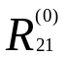 = φ, because there is no arc from state 2 to state 1.
Now, construct the expressions by considering the state 1. The rule for computing the expressions 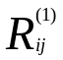 are
= 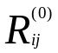 + 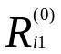 * 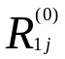
The following table gives first the expressions computed by direct substitution into the above formula, and then a simplified expression that we can show to represent the same language as the more complex expression.
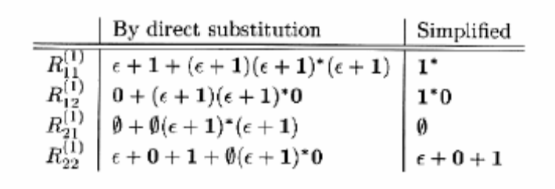
To understand the simplification, note the general principle that
- if R is any regular expression, then (ε +R)* = R*.
- In our case, we have (ε+1)* =1*; both expressions denote any number of 1’s.
- Also that (ε+1)1* = 1*,denotes any number of 1’s.
- Thus, the original expression 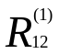 is equivalent to 0+1*0. This expression denotes the language containing the string 0 and all strings consisting of a 0 preceded by any number of 1’s. This language is also expressed by the simpler expression 1*0.
- For any regular expression R: φ R = R φ =φ. And φ+R = R+φ =R. That is, φ is the identity for union; it results in the other expression whenever it appears in a union.

Let us compute the expressions 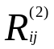. The inductive rule applied with k=2 give us:
= + 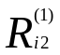 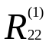 * 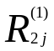

The expressions are given in the following table.
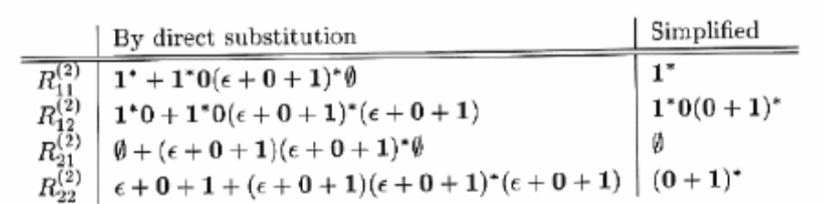
The final regular expression equivalent to the DFA is constructed by taking the union of all the expressions where the first state is the start state and the second state is accepting. In this eg., with 1 as the start state and 2 as the only accepting state, we need only the expression .
This expression is 1*0(0+1)*.
It is simple to interpret this expression. Its language consists of all strings that begin with zero or more 1’s, then have a 0, and then any string of 0’s and 1’s. In another way, the language is all strings of 0’s and 1’s with at least one 0.

Explain the conversion of DFA to regular expression. (or) (10 marks)
Describe the concepts of eliminating states in the conversion of DFA to Regular expression?

The regular expressions can be constructed by eliminating the states of DFA.
- When a state is eliminated, all the paths that went through s no longer exist in the automaton.
- Once a state is eliminated, the language will also change. So an arc must be included to connect its predecessor and successor.
- This arc will contain a string as a label.
- Regular expression is used to represent the string.
- Finally the language of the automaton is the union over all paths from the start state to an accepting state of the language formed by concatenating the languages of the regular expressions along that path.

The following figure(a) shows a generic state s about to be eliminated. The state s has predecessor states q₁,q₂,…….,q_{k} and successor states p₁,p_{2,}…….p_{m}.
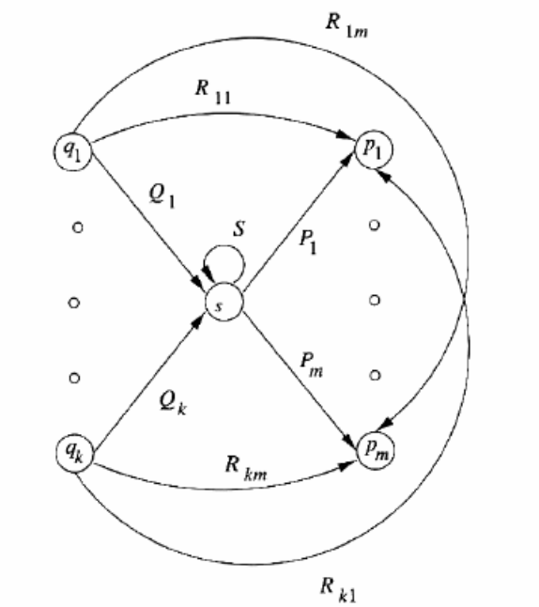 | 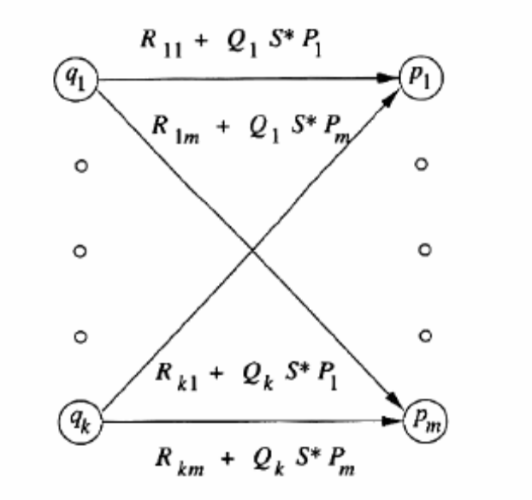
(a) | (b)

Fig.(b) shows what happens when we eliminate state s.
- All arcs involving state s are deleted.
- To compensate, we introduce, for each predecessor q_{i} of s and each successor p_{j} of s, a regular expression that represents all the paths that start at q_{i}, go to s, perhaps loop around s zero or more times.
- The expression for these paths is Q_{i} s* P_{j}. This expression is added to the arc from q_{i} to p_{j}.
- If there was no arc q_{i} → p_{j}, then first introduce one with regular expression φ.

The strategy for constructing a regular expression from a finite automaton is as follows:
- For each accepting state q, apply the above reduction process to produce an equivalent automaton with regular expression labels on the arcs.
- Eliminate all states except q and the start state q₀.
- If q ≠ q₀, then we shall be left with a two-state automaton that looks like as in the figure.
- The regular expression for the accepted strings can be described in various ways.
- One is (R+SU*T)* SU*.
  - In explanation, we can go from the start state to itself any number of times, by following a sequence of paths whose labels are in either L(R) or L(SU*T).
  - The expression SU*T represents paths that go to the accepting state via a path in L(S), perhaps return to the accepting state several times using a sequence of paths with labels in L(U), and then return to the start state with a path whose label is in L(T).
  - Then we must go to the accepting state, never to return to the start state, by following a path with a label in L(S).
  - Once in the accepting state, we can return to it as many times as we like, by following a path whose label is in L(U).
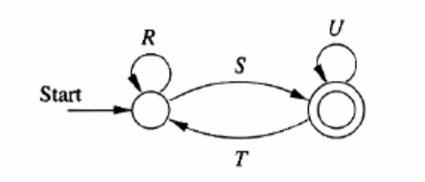
- If the start state is also an accepting state, then we must also perform a state-elimination from the original automaton that gets rid of every state but the start state .When we do so, we are left with a one-state automaton that looks like in the following figure. The regular expression is R*.
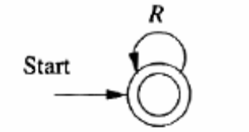
- The desired regular expression is the sum of all the expressions derived from the reduced automata for each accepting state, by rules (2) and (3).
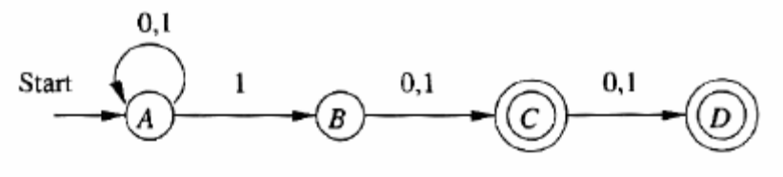
Eg: Let us consider the NFA in the above figure that accepts all strings of 0’s and 1’s such that either the second or third position from the end has a 1. Our first step is to convert it to an automaton with regular expression labels. Since no state elimination has been performed, all we have to do is replace the labels “0,1” with the equivalent regular expression 0+1. The result is shown in the following figure.
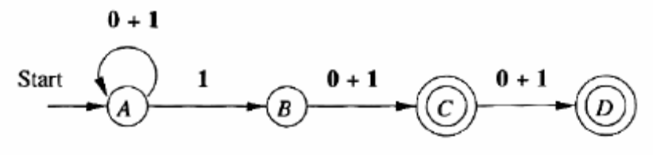
Let us first eliminate state B. Since this state is neither accepting nor the start state, it will not be in any of the reduced automata. State B has one predecessor, A, and one successor, C.
- As a result, the expression on the new arc from A to C is φ+1φ*(0+1).
- To simplify, we first eliminate the initial φ, which any be ignored in a union. The expression thus becomes 1φ*(0+1). Note that the regular expression φ* is equivalent to the regular expression ε.
- Thus, 1φ*(0+1) is equivalent to 1(0+1).
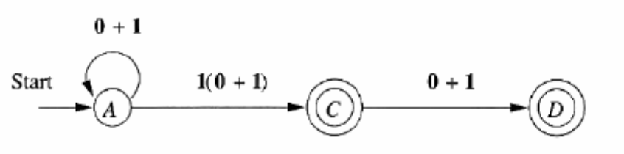
Now, we must branch, eliminating states C and D in separate reductions. To eliminate state C, and the resulting automaton is as shown in the figure.
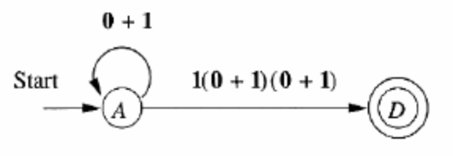
- In terms of the generic two-state automaton, the regular expressions are: R= 0+1, S=1(0+1)(0+1), T=φ, and U=φ. The expression U* can be replaced by ε.
- Also, the expression SU*T is equivalent to φ.
- The generic expression (R+SU*T)*SU* thus simplifies in this case to R*S, or (0+1)*1(0+1)(0+1). In informal terms, the language of this expression is any string ending in 1, followed by two symbols that are each either 0 or 1.
- That language is one portion of the strings accepted by the original automaton. those strings whose third position from the end has a 1.

Now we start again and eliminate state D instead of C. since D has no successors. The resulting two-state automaton is shown in the figure.
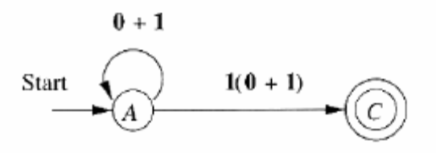
Thus, we can apply the rule for two-state automata and simplify the expression to get (0+1)*1(0+1). This expression represents the other type of string the automaton accepts: those with a 1 in the second position from the end. All that remains is to sum the two expressions to get the expression for the entire automaton. This expression is
(0+1)*1(0+1) + (0+1)*1(0+1)(0+1)

Describe the conversion of regular expression into automata? (or)
Explain the conversion of regular expression into finite automata? (10 marks)

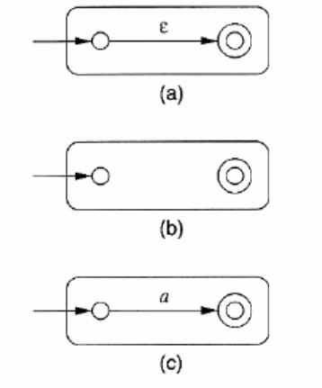
The automata can be constructed for single symbols ε, and φ. And they can be combined into larger automata that accept the union, concatenation, or closure of the language accepted by smaller automata. All of the automata we construct are ε-NFA’s with a single accepting state.

Theorem: Every language defined by a regular expression is also defined by a finite automaton.
Proof: Suppose L=L( R ) for a regular expression R. We show that L=L(E) for some ε-NFA E with:
- Exactly one accepting state
- No arcs into the initial state
- No arcs out of the accepting state

BASIS
There are three parts to the basis as shown in the figure.
- Part(a) shows to handle the expression ε. The language of the automaton is easily seen to be {ε}, since the only path from the start state to an accepting state is labeled ε.
- Part (b) shows the construction for φ. Clearly there are no paths from start state to accepting state, so φ is the language of this automaton.
- Finally, part (c) gives the automaton for a regular expression a. the language of this automaton consists of the one string a, which is also L(a). It is easy to check that these automata all satisfy conditions (1), (2) and (3) of the inductive hypothesis.

INDUCTION
The three parts of the induction are shown in the figure. It is assumed that the statement of the theorem is true for the immediate sub expressions of a given regular expression; that is, the languages of these sub expressions are also the languages of ε-NFA’s with a single accepting state. The four cases are:
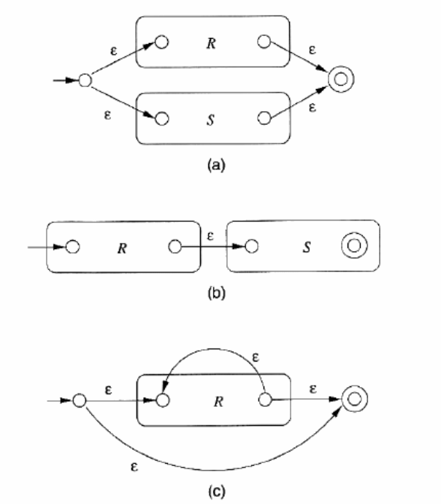
- The expression id R+S for some smaller expressions R and S. Then the automaton of fig(a) serves. That is, starting at the new start state, we can go to the start state of either R or S. We then reach the accepting state of one of these automata, following a path labeled by some string in L(R) or L(S). Once we reach the accepting state of the automaton for R or S, we can follow one of the ε-arcs to the accepting state of the new automaton. Thus, the language of the automaton in fig(a) shows L(R)∪L(S).
- The expression is RS for some smaller expression R and S. The automaton for the concatenation is shown in fig(b). Note that the start state of the first automaton becomes the start state of the whole, and the accepting state of the second automaton becomes the accepting state of the whole. The idea is that the only paths from the start state to accepting state go first through the automaton for R, where it must follow a path labeled by a string in L(R), and then through the automaton for S, where it follows a path labeled by a string in L(S). Thus, the paths in the automaton of fig(b) are all and only those labeled by strings in L(R) L(S).
- The expression is R* for some smaller expression R. Then we use the automaton of fig(c). That automaton allows us to go either.
  - Directly from the start state to the accepting state along a path labeled ε which is in L(R)* no matter what R is.
  - To the start state of the automaton for R through that automaton one or more times, and then to the accepting state. This set of paths allows us to accept in L(R), L(R) L(R), L(R) L(R) L(R), and so on, thus covering all strings in L(R)* except ε which was covered by direct arc to the accepting state mentioned in 3(a).
- The expression is (R) for some smaller expression R. The automaton of R also serves as the automaton for (R) since the parenthesis do not change the language defined by the expression.

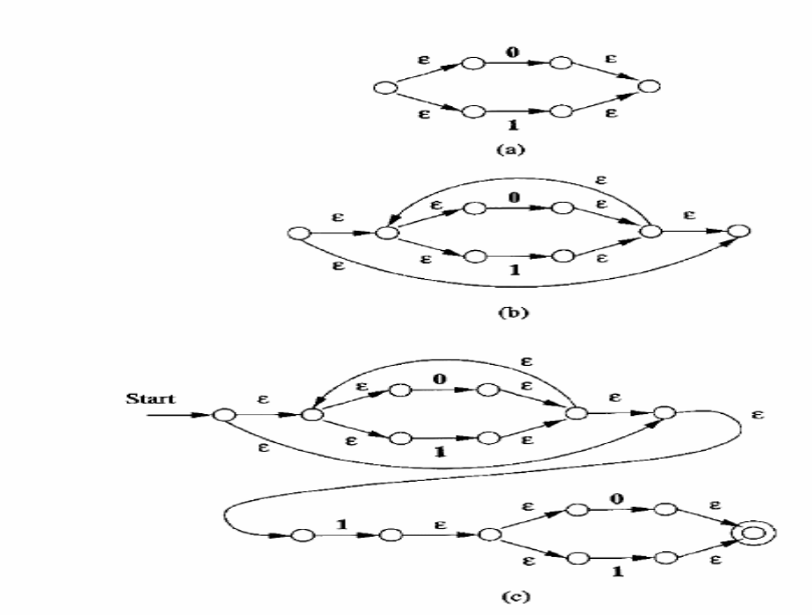
Conclusion: It is a simple observation that the constructed automata satisfy the three conditions given in the inductive hypothesis. One accepting state, with no arcs into the initial state or out of the accepting state.

Example
Let us convert the regular expression (0+1)*1(0+1) to an ε-NFA.
- Our first step is to construct an automaton for 0+1.
- Next, we apply closure operation.
- The third automaton in the concatenation is another automaton for 0+1.
- The step by step construction is shown in the figure.

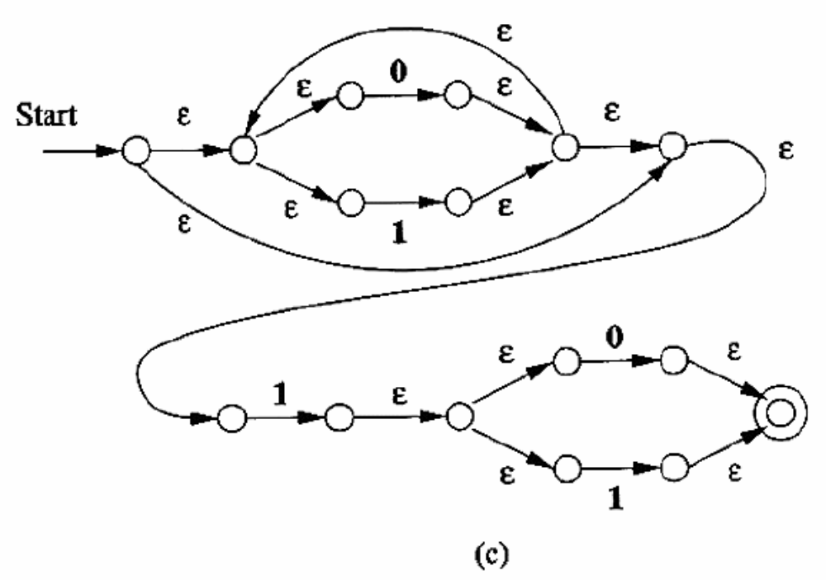
State the algebraic laws for regular expressions. (or)
Explain the Algebraic laws available in regular expressions. (10 marks)

Like arithmetic expressions, the regular expressions have a number of laws that work for them. Many of these are similar to the laws for arithmetic, if we think of union as addition and concatenation as multiplication.

Commutativity

Commutativity is the property of where the order of its operands can be switched and gets the same result. An example for arithmetic is given as x+y = y+x.
- L+M = M+L. This law, the commutative law for union, says that we may take the union of two languages in either order.

Associativity

Associativity is the property of an operator that allows us to group the operands when the operator is applied twice. For eg., the associative law of multiplication is (x × y) × z = x × (y × z).
- (L+M)+N = L+(M+N). The union of three languages either by taking the union of the last two initially, or taking the union of the last two initially.
- (LM)N =L(MN). This law, the associative law for concatenation, says that we can concatenate three languages by concatenating either the first two or the last two initially.

Identities

An identity for an operator is a value such that when the operator is applied to the identity for addition, since 0+x = x+0=x, and 1 is the identity for multiplication, since 1 × y = y × 1 = y.
- φ + L = L + φ = L. This law asserts that φ is the identity for union.
- εL = Lε =L. This law asserts that ε is the identity for concatenation.

Annihilators

An annihilator for an operator is a value such that when the operator is applied to the annihilator and some other value, the result is the annihilator. For instance, 0 is an annihilator for multiplication, since 0 × y = y × 0 =0. There is no annihilator for addition.
- φL = Lφ=φ . This law asserts that φ is the annihilator for concatenation.

Distributive Laws:

A distributive law involves two operators, and asserts that one operator can be pushed down to be applied to each argument of the other operator individually. The most common example from arithmetic is the distributive law of multiplication over addition, that is x × (y + z) = x × y + x × z. Two types are
- L(M+N) = LM + LN. This law, is the left distributive law of concatenation over union.
- (M+N)L = ML + NL. This law, is the right distributive law of concatenation over union.

The Idempotent Law:

An operator is said to be idempotent if the result of applying it to two of the same values as arguments is that value. The common arithmetic operators are not idempotent; x +x ≠ x in general and x × x ≠ x in general. However, union and intersection are common examples of idempotent operators. Thus, for regular expressions,
- L+L=L This law, the idempotent law for union, states that if we take the union of two identical expressions, we can replace them by one copy of the expression.

Laws involving closures:

There are a number of laws involving the closure operators as given below
- (L*)* This law says that closing an expression that is already closed does not change the language. That is (L*)* L*
- φ* = ε. The closure of φ contains only the string ε.
- ε* = ε. It is easy to check that the only string that can be formed by concatenating any number of copies of the empty string is the empty string itself.
L⁺ = LL* = L*L
- L* = L⁺ + ε.

Describe the pumping Lemma for regular languages and applications of the pumping Lemma. (or)
Prove that the languages are not to be regular. (10 marks)

Regular languages have atleast four different descriptions. They are the languages accepted by DFA’s, by NFA’s and by ε-NFA’s; they are also the languages defined by regular expressions. Not every language is a regular language. We shall introduce a powerful technique, known as the “pumping lemma” for showing certain languages not to be regular.

The Pumping Lemma for Regular Languages

- Let us consider the language L₀₁ = { 0^{n}1^{n} | n ≥ 1}. This language contains all strings 01, 0011, 000111, and so on, that consist of one or more 0’s followed by an equal number of 1’s.
- L₀₁ is not a regular language.
- Since it was in some state q when the 1’s started, it cannot “remember” that how number of 0’s it has received already. So this language can’t be represented by using automata and regular expression.

The pumping lemma for regular languages

Let L be a regular language. Then there exists a constant n such that for every string w in L such that | w | ≥ n, the string w can be divided into three strings, w = xyz, such that:
- y≠ε
- | xy | ≤ n
- For all k ≥ 0, the string xy^{k}z is also in L.

Then L= L(A) for some DFA A. Suppose A has n states. Now, consider any string w of length n or more, say w = a₁a₂……a_{m}, where m ≥ n and each a_{i} is an input symbol. now, we can break w = xyz as follows:
- x=a₁a₂…..a_{i}
- y = a_{i+1}a_{i+2}…..a_{j}
- z = a_{j+1}a_{j+2}…..a_{m}
The following figure shows the DFA for the regular languages.
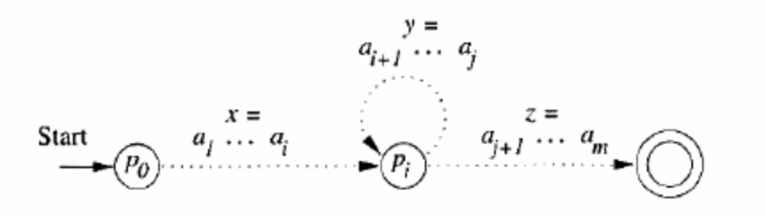

Write short notes on Decision properties of Regular Languages (or)
Explain Regular Languages based on decision properties. (10 marks)

Consider some of the fundamental questions about languages:
- Is the language described empty?
- Is a particular string w in the described language?
- Do two descriptions of a language actually describe the same language? This question is often called “equivalence” of languages.

- CONVERTING AMONG REPRESENTATIONS

We can convert any of the four representations for regular languages to any of the other three representations. While there are algorithms for any of the conversions, sometimes we are interested not only in the possibility of making a conversion, but in the amount of time it takes.

Converting NFA’s to DFA’s

- When we start with either an NFA or ε-NFA and convert it to a DFA, the time can be exponential in the number of states of the NFA.
- First, computing the ε-closure of n states takes O(n³) time.
- Once the ε-closure is computed, we can compute the equivalent DFA by the subset construction.
- Then from the subset, the reachable states from the starting state and their corresponding outputs are considered for the DFA

DFA-to-NFA conversion

Modify the transition table for the DFA by putting set-brackets around states and, if the output is an ε-NFA, adding a column for ε. Since we treat the number of input symbols as a constant, copying and processing the table takes O(n) time.

Automaton-to-Regular Expression conversion

The n³ expressions can take time O(n³4^{n}).The same construction works in the same running time if the input is an NFA, or an ε-NFA. If we first convert an NFA to a DFA and then convert the DFA to a regular expression, it could take time O(n³4^{n2}), which is doubly exponential.

Regular-Expression –to-Automaton Conversion

Conversion of a regular expression to an ε-NFA takes linear time. We need to parse the expression efficiently, using a technique that takes only O(n) time on a regular expression of length n⁴. The result is an expression tree with one node for each symbol of the regular expression. Once we have an expression tree for a regular expression, we can work up the tree, building the ε-NFA for each node.

- TESTING EMPTINESS OF REGULAR LANGUAGES

“Is regular language L empty?” The answer is: φ is empty and all other regular languages are not. If our representation is any kind of finite automaton, the emptiness question is whether there is any path whatsoever from the start state to some accepting state. If so, the language is nonempty, while if the accepting states are all separated from the start state, then the language is empty. The algorithm can be summarized by this recursive process.

BASIS The start state is surely reachable from the start state.
INDUCTION Compute the set of reachable states from each state. If the set contains any accepting state, then the language is nonempty otherwise it is empty.

The following recursive rules tell whether a regular expression denotes the empty language.
BASIS φ denotes the empty language; ε and a for any input symbol a do not.
INDUCTION Suppose R is a regular expression. There are four cases to consider, corresponding to the ways that R could be constructed
- R = R₁ + R₂. Then L(R) is empty if and only if both L(R₁) and L(R₂) are empty.
- R = R₁R₂. Then L(R) is empty if and only if either L(R₁) or L(R₂) is empty.
- R = R₁*. Then L(R) is not empty; it always includes at least ε.
- R = (R₁). Then L(R) is empty if and only if L(R₁) is empty, since they are the same language.

- TESTING MEMBERSHIP IN A REGULAR LANGUAGE

Given a string w and a regular language L, the problem is to find out whether the given string can be accepted by the language or not. While w is represented explicitly, L is represented by an automaton or regular expression.

- If the language L is represented by an automaton, then for the given string, if the DFA ends in an accepting state, the answer is “yes”; otherwise the answer is “no”.
- If L has any other representation besides a DFA, like NFA, then we could convert to a DFA and run the test above.
- If the NFA has ε-transitions, then we must compute the ε-closure before starting the simulation. Then the processing of each input symbol a has two stages, each of which requires O(s²) time.
- Lastly, if the representation of L is a regular expression of size s, we can convert to an ε-NFA with at most 2s states, in O(s) time. We then perform the simulation above, taking O(ns²) time on an input w of length n.

- EQUIVALENCE AND MINIMIZATION OF AUTOMATA

In this, we discuss how to test whether two descriptors for regular languages are equivalent, in the sense that they define the same language. An important consequence of this test is that there is a way to minimize a DFA. That is, we can take any DFA and find an equivalent DFA that has the minimum number of states.

Describe about Testing Equivalence of states. (or)
Explain about the testing equivalence of states. (10 marks)

Our goal is to understand when two distinct states p and q can be replaced by a single state that behaves like both p and q. We say that states p and q are equivalent if:
- For all input strings w, p must be accepting state if and only if q is an accepting state.
- Both are accepting or both are non-accepting.
- If two states are not equivalent, then we say they are distinguishable.
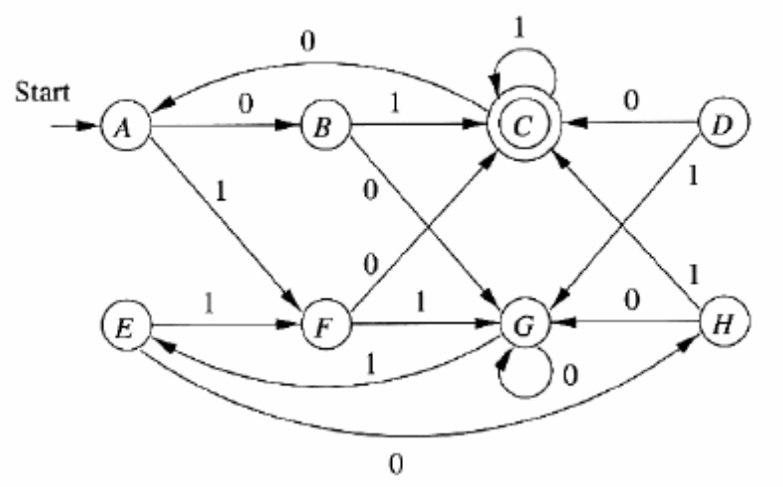
For example consider the DFA,
- C and G are not equivalent because one is accepting and the other is not.
- Consider states A and G.
  - String ε doesn’t distinguish them because both are non-accepting states.
  - For String 0, they go to states B and G, and both states are non-accepting.
  - Likewise, string 1 doesn’t distinguish A from G, because they go to F and E, respectively, and both are non-accepting.
  - However, 01 distinguishes A from G, because δ(A,01) = C, δ(G, 01) = E, C is accepting, and E is not.
  - So the states A and G are not equivalent.
- In contrast, consider states A and E.
  - Neither is accepting, so ε does not distinguish them.
  - On input 1, they both go to state F.
  - With 0, they go to states B and H, respectively. Since neither is accepting, string 0 by itself does not distinguish A from E.
  - On input 1 they both go to C, and on input 0 they both go to G. Thus, all inputs that begin with 0 will fail to distinguish A from E.
  - So both are equivalent states.

To find states that are equivalent, we make our best efforts to find pairs of states that are distinguishable. The following table-filling algorithm is used to find out the non-equivalent state pairs.

BASIS If p is an accepting state and q is non accepting, then the pair {p,q} is distinguishable.

INDUCTION: Let p and q be states such that for some input symbol a, r = δ(p, a) and s = δ(q, a) are a pair of states known to be distinguishable. Then {p,q} is a pair of distinguishable states.

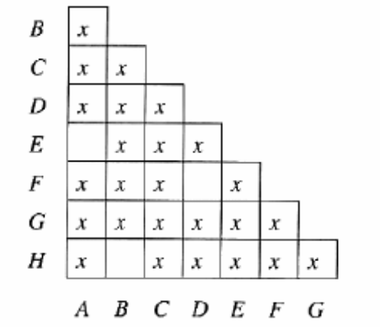
Execute the table-filling algorithm on the above DFA. The final table is shown in the following figure, where an x indicates pairs of distinguishable states, and the blank squares indicate those pairs that have been found equivalent. Initially, there are no x’s in the table.

- For the basis, since C is the only accepting state, we put x’s in each pair that involves C.
- For instance, since {C,H} is distinguishable, and states E and F go to H and C, respectively, on input 0, we know that {E,F} is also a distinguishable pair.
- The pair {A,G} can be discovered simply by looking at the transitions from the pairs of states on either 0 or 1, and observing that one state goes to C and the other does not.
- We can show {A.G} is distinguishable on the next round, since on input 1 they go to F and E, respectively, and we already established that the pair{E,F} is distinguishable.
- The three remaining pairs, which are therefore equivalent pairs, are {A,E}, {B,H}and {D,F}.
- For eg., consider why we cannot infer that {A,E} is a distinguishable pair. On input 0, A and E go to B and H, respectively, and {B,H} has not yet been shown distinguishable. On input 1, A and E both go to F, so there is no hope of distinguishing them that way.
- The other two pairs, {B,H} and {D,F} will never be distinguished because they each have identical transitions on 0 and identical transitions on 1.
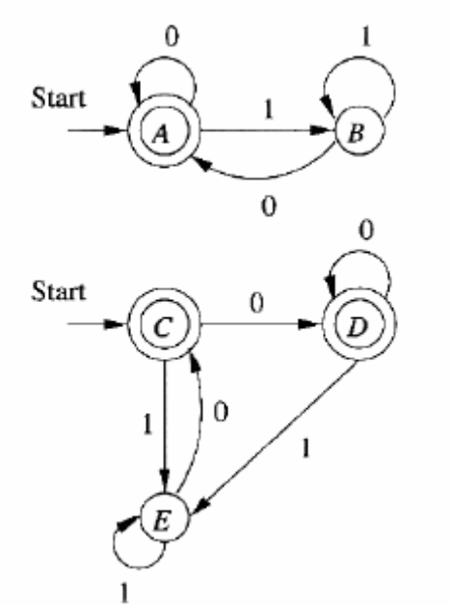
- Thus, the table-filling algorithm steps with the table as shown in figure, which is the correct determination of equivalent and distinguishable states.

Testing Equivalence of Regular Languages

The table-filling algorithm gives us an easy way to test if two regular languages are the same. Suppose languages L and M are each represented in some way, eg., one by a regular expression and one by an NFA. Convert each representation to a DFA. Now, imagine one DFA whose states are the union of the states of the DFA’s for L and M. Technically, this DFA has two start states, but actually the start state is irrelevant as far as testing state equivalence is concerned, so make any state the lone start state.

Now, test if the start states of the two original DFA’s are equivalent, using the table-filling algorithm. If they are equivalent, then L=M and if not, then L≠M.

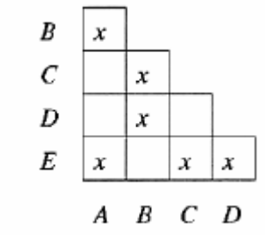
Example: Consider the two DFA’s in the figure. Each DFA accepts the empty string and all strings that end in 0; that is the language of regular expression ε+(0+1)*0. We can imagine that the figure represents a single DFA, with five states A through E. If we apply the table-filling algorithm to that automaton, the result is as shown in the figure.

To see how the table is filled out, we start by placing x’s in all pairs of states where exactly one of the states is accepting. It turns out that there is no more to do. The four remaining pairs,{A,C},{A,D},{C,D} and {B,E} are all equivalent pairs. You should check that no more distinguishable pairs are discovered in the inductive part of the table-filling algorithm. For instance, with the table as in fig.4.11, we can’t distinguish the pair {A,D} because on 0 they go to themselves and on 1 they go to the pair {B,E}, which has not yet been distinguished. Since A and C are found equivalent by this test, and those states were the start states of the two original automata, we conclude that these DFA’s do accept the same language.

Explain about Minimization of DFA’s. (or)
Give a brief note on Minimization of DFA’s. (10 marks)

For each DFA we can find an equivalent DFA that has a few states as any DFA accepting the same language. The central idea behind the minimization of DFA’s is that the notion of state equivalence lets us partition the states into blocks such that:
- All the states in a block are equivalent
- No two states chosen from two different blocks are equivalent.
Example
- Consider the first DFA and the table of the previous question, where we determined the state equivalences and distinguishabilities for the states in the DFA. The partition of the states into equivalent blocks is ({A,E},{B,H},{C},{D,F},{G}).
- Notice that the three pairs of states that are equivalent are each placed in a block together, while the states that are distinguishable from all the other states are each in a block alone.
- For the automaton of second DFA, the partition is ({A,C,D},{B,E}).This example shows that we can have more than two states in a block. It may appear that A, C and D can all live together in a block, because every pair of them is equivalent, and none of them is equivalent to any other state.

Consider the first DFA, The start state is {A,E},since A was the start state of the DFA. The only accepting state is {C}, since C is the only accepting state of DFA. The transitions of the following figure properly reflect the transitions of original DFA. For instance, it has a transition on input 0 from {A,E} to {B,H}. If we examine the original DFA, we find that both A and E go to F on input 1, so the selection of the successor of {A,E} on input 1 is also correct. Check that all of the other transitions are also proper.

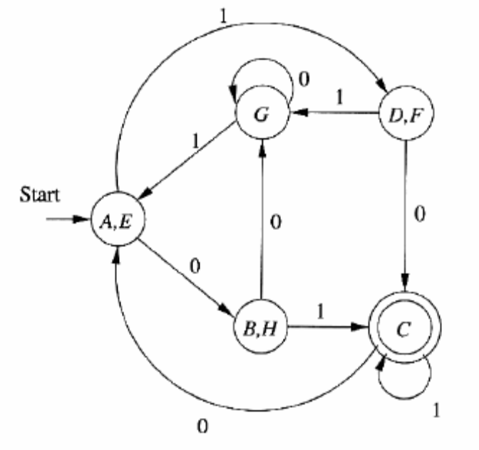
Write short notes on Moore and Mealy machines. (or) (10 marks)
Explain Moore and Mealy machines.

One limitation of the finite automaton as we have defined it is that its output is limited to a binary signal: “accept” / “don’t accept.” Model in which the output is chosen form some other alphabet have been considered .There are two distinct approaches; the output may be associated with the state (called a Moore machine) or with the transition (called a Mealy machine). We shall define each formally and then show that the two machine types produce the same input-output mappings.

Moore machines
A Moore machine is a six-tuple (Q, Σ, Δ, λ, õ,q0) , where Q, Σ, õ and q0 are as in the DFA. Δ is the output alphabet and λ is a mapping from Q to Δ giving the output associated with each state. The output of M in response to input a1,a2 .... an , n≥0, is λ (q0) λ (q1) …. λ (qn), where q0,q1, ….. qn is the sequence of states such that õ (qi-1,a1) = qi for 1≤ i ≤ n. Note that any Moore machine gives output λ (q0) in response to input ε. The DFA may be viewed as a special case of a Moore machine where the output alphabet is {0,1} and state q is “accepting” if and only if λ (q)=1.
Example :
q0
q1
q2
0
0
0
1
1
1
A Moore machine calculating residues
Suppose we wish to determine the residue mod 3 for each binary string treated as a binary integer. To begin, observe that if I written in binary is followed by a 0, the resulting string has value 2i, and if I in binary is followed by a remainder of 2i/3 is 2p mod 3. If p = 0, 1, or 2, then 2p mod3 is 0, 2, or1, respectively. Similarly, the remainder of (2i+1)/3 is 1, 0, or 2, respectively. It suffices therefore to design a Moore machine with three states, q0, q1, and q2, where qj is entered if and only if the input seen so far the residue j. We define λ(qj) = j for j = 0, 1, and 2 .

In the above transition diagram, where outputs label the states. The transition function T is designed to reflect the rules regarding calculation of residues described above. On input 1010 the sequence of states entered is q0,q1,q2,q2,q1, giving output sequence 01221. That is, E (which has “value”0) has residue 0, 1 has residue 1,2 (in decimal) has residue 2 , and 10 (in decimal) has residue 1.

Mealy machines
A Mealy machine is also a six-tuple M = (Q, Σ, Δ, λ, õ, q0), where all is as in the Moore machine, except λ that maps Q * Σ to Δ. That is, λ(q,a) gives the output associated with the transition from state q on input a, The output of M in response to input a1,a2 …. An is λ (q0,a1) λ (q1,a2) …. λ (qn-1,an), where q0,q1, ….. qn is the sequence of states such that õ (qi-1,a1) = qi for 1 ≤ i ≤ n. Note that this sequence has length n rather than length n + 1 as for the Moore machine, and on input ε a Mealy machine gives output ε.
q0
P0
P1
start
0/n
0/4
1/n
0/n

1/n

1/4

Mealy machine

Example
Even if the output alphabet has only two symbols, the Mealy machine model can save states when compared with a finite automation. Consider the language (0 + 1)*(00 + 11) of all strings of 0’s and 1’s whose last two symbols are the same. In the next chapter we shall develop the tools necessary the show that this language is accepted by no DFA with fewer than five states. However, we may define a three-state Mealy machine that uses its state to remember the last symbol read, emits output y whenever the current input matches the precious one, and emits n otherwise. The sequence of y’s and n’s emitted by the Mealy machine corresponds to the sequence of accepting and non accepting states entered by a DFA on the same input; however, the Mealy machine does not make an output prior to any input, while the DFA rejects the string E, as its initial state is nonfinal.

The Mealy machine M = ({q0,p0,p1},{0,1},{y,n}, õ, λ,q0) is shown in below figure. We use the label a/b on an arc from state p to state q to indicate that õ (p,a) = q and λ (p , a) = b. The response of M to input 01100 is nnyny, with the sequence of states entered being q0p0p1p1p0p0. Note how p0 remembers a zero and p1 remember a one. State q0 is initial and “remembers” that no in

 End of Unit -2 

U N I T - III

Explain Context Free Grammar (CFG) with example? (or)
Explain the components of context free grammar? (5 marks)

There are four important components in a grammatical description of language:
- There is a finite set of symbols that form the strings of the language being defined. This set was {0,1}.We call this alphabet the terminals or terminal symbols.
- There is a finite set of variables also called sometimes non-terminals or syntactic categories. Each variable represents a language that is a set of strings.
- One of the variables represents the language being defined; it is called the start symbol. Other variables represent auxiliary classes of strings that are used to help define the language of start symbol.
- There is a finite set of productions or rules the represents the recursive definition of a language. Each production consist of
  - A variable that is being defined by the production and it is being defined by the production and it is called as the head of the production.
  - The production symbol→.
  - A string of zero or more terminals and variables. This string called the body of the production represents one way to form strings in the language of the variable of the head.
The CFG G can be represented by its 4 components that is G=(V,T,P,S)
V → set of variables
T → terminals
P → set of productions
S → start symbol.

Example-1: Consider the context free grammar for palindromes.
- P → ε
- P → 0
- P → 1
- P → 0P0
- P → 1P1
The grammar G_{pal} for palindrome is represented by: G_{pal=}({p},{0,1},A,P)
where A represents the set of 5 production as seen above.

Example-2: Consider the set of identifiers only with the letters a, b and the digits 0 and 1. Every identifier must begin with a or b, which may be followed by any string in {a,b,0,1} . We need two variables in this grammar one we call E, represents the expressions. It is the start symbol and represents the language of expressions we are defining. The other variable I represents the identifier. The regular expression for the language is (a+b) (a+b+0+1)*. This expression can be converted into a CFG as follows:
- E → I
- E → E + E
- E → E * E
- E → ( E )
- I → a
- I → b
- I → Ia
- I → Ib
- I → I0
- I → I1
The grammar for expressions is started finally as G = ({E,I},T,P,E) where T is the set of symbols {+,*,(,)a,b,0,1} and P is the set of productions shown above.

- Rule (1) is the basis rule for expressions. It says that expressions can be a single identifier.
- Rule (2) through(4) describe the inductive case fro expressions.
- Rule(2) say that an expression can be two expressions connected by a plus sign,
- Rule (3)says the same with a multiplication sign.
- Rule (4) says that if we take any expression and put matching parentheses around it, the result is also an expression.
- Rules(5) through(10) describe identifiers. I.
- The basis is rules(5)and (6); they say that a and b are identifiers. The remaining 4 rules are the inductive case, They say that if we have any identifier, we can follow it by a,b,0(or)1, and the result will be another identifiers.

Discuss the derivations of grammars with example? (or)
Write short notes on (i) Recursive inference and (ii) Derivations? (5 marks)

There are two approaches found for the inference of CFG. The more conventional approach is to use the rules from body to head. We take strings known to be in the language of each of the variable of the body, concatenate them, in the proper order with any terminals appearing in the body and infer that the resulting strings is in the language of the variable in the head. We shall refer to this procedure as recursive inference.

Example:
Let us consider some of the inferences we make using the grammar for expression (a+b) (a+b+0+1)*. For example, line (i) says that we can infer string a is in the languages for I by using production 5. Lines (ii) through (iv) says we can infer that b00 is an identifier by using production 6 once(to get the b) and then applying production 9 twice(to attach the two 0’s).
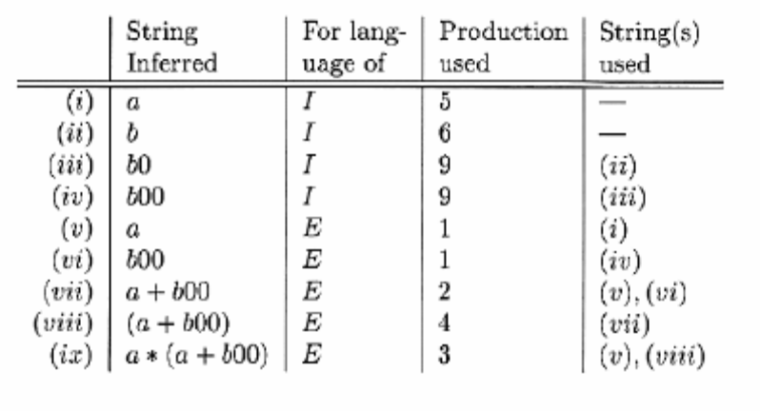
Lines (v) and (vi) exploit production 1 to infer that, since that any identifier is an expression, the strings a and b₀₀ , which we inferred in lines (i) and (iv) to be identifiers are also in language of variable E. Line(vii) uses production 2 to infer that the sum of these identifiers is an expression, line(viii) uses production 4 to infer that the same string with parentheses around it is also an identifier and line(ix) use production 3 to multiply the identifier a by the expression we had discovered in line(viii).

There is another approach to define the language of a grammar, in which we use the productions from head to body. We expand the start symbol using one of its productions. We further expand the resulting string by replacing on of the variables by the body of one of its production and so on, until we derive a string consisting entirely of terminals. The language of grammar is all strings of terminals that we can obtain in this way. This use of grammar is called Derivations.

The process of deriving strings by applying productions from head to body requires the definition of a new relation symbol ⇒. Suppose G=(V,T,P,S) is a CFG.
- Let A → α γ be a production of G. Then we say Aβ ⇒ α γ β.
- We may entered the ⇒ relationships to represent zero, one or many derivation steps, For derivation we use a * to denote “zero or more steps”.

Example: The inference that a * (a+b00) is in the language of variable E can be reflected in a derivation of that string, starting with the string E. Here is one such derivation.

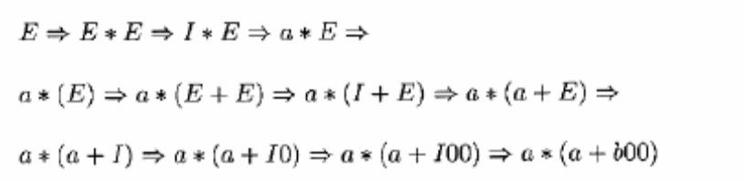

Give short notes on left most and rightmost derivations? (or)
Discuss LMD and RMD? (5 Marks)

To restrict the number of choices we have in deriving a string, it is often useful to require that at each step, we replace the leftmost variable by one of its production bodies such a derivation is called as leftmost derivation and we indicate that a derivation is leftmost by using the relations 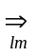 and, 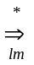 for one or many steps respectively. If the grammar G that is being used is not obvious, we can place the name G below these symbols if it is not clear which grammar is being used.

Similarly it is possible to require that at each step the rightmost variable is replaced by one of its bodies, if so, we call the derivation rightmost and use the symbols 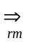 and, 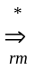 to indicate one or more rightmost derivation steps, respectively. Again the name of the grammar may appear below these symbols if it is not clear which grammar is being used.

Example:
Construct LMD for the given string w=a * ( a+b00) by considering the production for (a+b)(a+b+0+1)*.

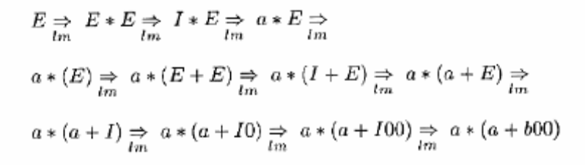
There is a rightmost derivation that user the same replacements for each variable, although it makes the replacement in different order. This rightmost derivation is

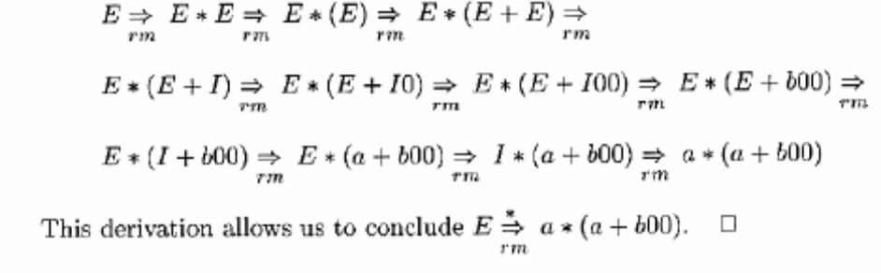

Any derivation has an equivalent leftmost and an equivalent rightmost derivation.

Explain Context Free Language? (or)
Explain the language of the given grammar? (5 marks)

If G(V,T,P,S) is a CFG, the language of G, denoted L(G), is the set of terminal strings that have derivations from the start symbol. That is

L(G) = { w in T | S 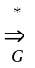 w }

If a language L is the language of some context free grammar, then L is said to be a context free language or CFL. For instance, we asserted that the grammar of the language of palindromes over alphabet {0,1}. Thus the set of palindrome is a context free language.

Ex: Context free grammar for palindromes.
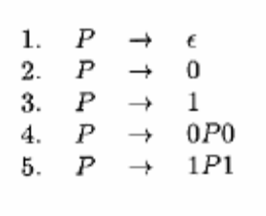

Explain sentential form with example? (or)
Explain right sentential form and left sentential form? (5 marks)

Derivations from the start symbol produce strings that have a special role. We call these “sentential forms”.

That is if G=(V,T,P,S) is a CFG, then any string α in (V U T)* such that
- s ⇒ α is a sentential form.
- If s α , then α left sentential form and if
- s α ,then α is a right sentential form.
- Note that the language L(G) is those sentential forms that are in T*, that is they consist solely of terminals.

Consider the grammar for expressions. For example E*(I+E) is a sentential form, since there is a derivation
E ⇒ E*E
⇒ E*(E)
⇒ E*(E+E)
⇒ E*(E+I)
However this derivation is neither leftmost nor rightmost, since at the last step, the middle E is replaced. As an example of left-sentential form, consider a*E, with the leftmost derivation.
E ⇒ E*E
⇒ I*E
⇒ a*E
Additionally the derivation
E ⇒ E*E
⇒ E*(E)
⇒ E*(E+E)
shows that E*(E+E) is a right sentential form.

Write short notes on parse trees? (or)
Explain the construction of parse trees? (or)
Give the construction of parse tree with example? (10 marks)

There is a tree representation for derivations that has proved extremely useful. This tree shows clearly how the symbols of a terminal string are grouped into substrings, each of which belongs to the language of one of the variables of the grammar. The trees are known as “parse tree”. In compiler the tree structure of the source program facilitates the translation of the source program into executable code by allowing natural, recursive functions to perform this translation process.

Let us fix on a grammar G = (V,T,P,S). The parse tree for G is a tree with the following condition.
- Each interior node is labeled by a variable in V.
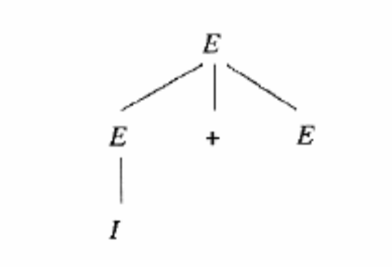
- Each leaf is labeled by a variable, a terminal, or ε. However, if the leaf is labeled ε, then it must be the only child of its parent.
- If an interior node is labeled A, and its children are labeled
X1,X2,……….,X_{k.}
respectively from the left, then A → x1,x2,……….,x_{k.} is a production in P. Note that the only one time one of the x’s can be ε is if that is the label of the only child, and A→ ε is a production of G.

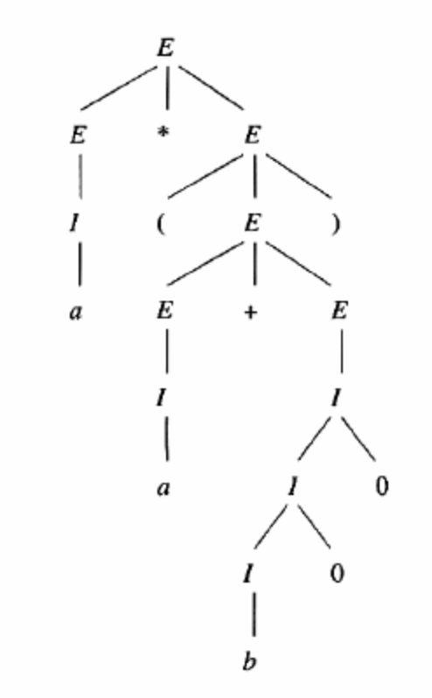
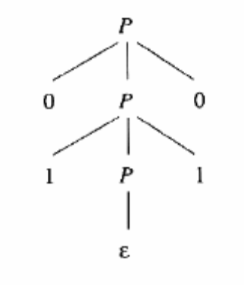
The following figure shows a parse tree denoting the derivation of I + E from E. The fig(b) shows a parse tree showing the derivation P ⇒ 0110
The yield of the parse tree:

If we concatenate the leaves of the parse tree from the left, we get a string called the yield of the tree, which is always a string derived from root variable.

The special importances of parse tree are
- The yield is a terminal string. That is all leaves are labeled either with a terminal or with ε.
- The root is labeled by the start symbol.

The following figure is an example of a tree with a terminal string as yield and the start symbol at the root. This particular parse tree is the representation of that derivation a*(a+b00).

Give a brief note on the Inferences, Derivations & Parse Trees? (10 marks)

Given grammar G=(V,T,P,S), we shall show that the following are equivalent.
- The recursive inference determines that terminal string ‘w’ is in the language of variable A.
- 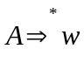
- 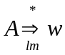
- 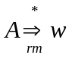
- There is a parse tree with root A and yield w.
In fact, except for the use of recursive inference, which we only defined for terminal strings all the other conditions - the existence of derivations, leftmost or rightmost derivations, and parse trees are also equivalent if w is a string that has some variables. That is each are in that diagrams indicates that we prove a theorem that says if w meets the condition at the trail, then it meets the condition at the head of the arc.
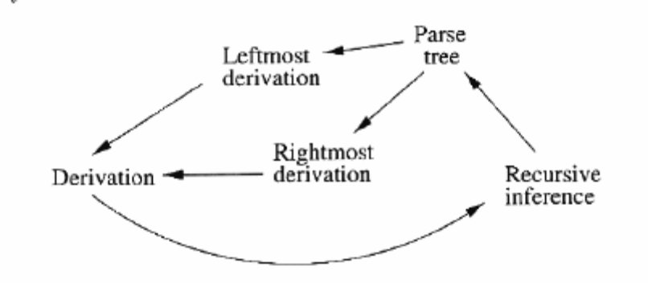
From Inference to Trees:-
A
w
Let G= (V,T,P,S) be a CFG. If the recursive inference procedure tells us that the terminal string w is in the language of variable A, then there is a parse tree with root A and yield w.

From Trees to Derivation

In order to understand how derivations may be constructed, we need first to see how one derivation of a string from a variable can be embedded within another derivation. Let us consider the expression grammar. It is easy to cheek that there is a derivation
E ⇒ I ⇒ Ib ⇒ ab
As a result, for any string α and β, it is also true that
α E β ⇒ α I β ⇒ α Ib β ⇒ α ab β
The justification is that we can make the same replacements of production bodies of for heads in the context of α and β. For instance if we have a derivation that begins E ⇒ E+E ⇒ E+(E), we could apply the erivation of ab from the second E by treating “E+(” as α and “)” as β. This derivation would then continue
E+E ⇒ E+(I) ⇒ E+(Ib) ⇒ E+(ab).

Ex2: Let us construct the leftmost derivation from the following tree.

E ⇒ E * E
⇒ I * E
⇒ a * E
⇒ a * ( E )
⇒ a * ( E + E )
⇒ a * ( I + E )
⇒ a * ( a + E )
⇒ a * ( a + I )
⇒ a * ( a + I0 )
⇒ a * ( a + I00 )
⇒ a * ( a + b00 )

From Derivations to Recursive Inferences

Whenever there is a derivation A ⇒ w for some CFG, then the fact that w is in the language of A is discovered in the recursive inference procedure. Suppose that we have a derivation
A ⇒ X1,X2,……….X_{k} ⇒ w.
Then we can break w into pieces w=w1,w2,……….. .w_{k} such that X_{i} ⇒ w_{i}. Note that if X_{i} is a terminal, then w_{i}=X_{i}, and the derivation is zero steps.

If X_{i} is a variable, we can obtain the derivation of X_{i} ⇒ w_{i} by starting with the derivation A ⇒ w and stripping away.
- All the position of the sentential forms that are either to the left or right of the positions that are derived from X_{i}.
- All the steps are not relevant to the derivation of w_{i} from X_{i}.

Explain the formal definition of push down automata? (or)
Give short notes on the definition of push down automata? (5 marks)

Our formal definition or notation for pushdown automation (PDA) involves seven components. We write the specification of a P= (Q, Σ, ⎡, δ, q₀, Z₀, F)

The components have the following meanings.
Q A finite set of states, like the states of a finite automation.
Σ A finite set of input symbols.
⎡ A finite set of symbols that are allowed to push onto the stack.
δ The transition function. Formally, δ takes as argument a triples (q,a,X) where
- q is state in Q.
- a is either an input symbol or ε
- X is a stack symbol that is a member of F.
q₀ The stack state, The PDA is in this state before making any transition.
Z₀ The start symbol initially, the PDA’s stack consists of one instance of this symbol and nothing else.
F The set of accepting states or final states.

Example
Let us design a PDA p to accept the language L_{wnR.} Of we shall use the stack symbol, z0 to mark the bottom of the stack. We need to have this symbol present so that, after we pop w off the stack and realize that we have seen ww^{R} on the input we still have something or the stack to permit us to make a transition to the accepting state q2. Thus our PDA for L_{wnr} can be described as

p=({q0,q1,q2},{0,1}{0,1,z0},δ q0,z0,{q2})

Where S is defined by the following rules.
- δ(q₀,0,Z₀)={(q0,0Z₀)} and δ(q0,1, Z₀)={(q0,1Z₀)}. One of these rules applies initially, when we are in state q₀ and we see the stack symbol Z₀ at the top of the stack. We need the first input and push it once the stack, leaving Z₀ below to mask the bottom.
- δ (q0,0,0)={(q0,00)}, δ(q0,0,1)={(q0,01)}, δ(q0,1,0)={(q0,10)}, δ(q0,1,1)={(q0,11)}. These 4, similar rules allow us to ones the top of the stack ands leaving the previous top stack symbol alone.
- δ(q0, ε,Z₀)={(q1,Z₀)} and δ(q0, ε,0)={(q1,0)}and δ(q0, ε,1)={(q,1)}. These 3 rules allow P to go from state q0 to state q1 spontaneously (on ε input) leaving the symbol at the top of the stack as it is.
- δ={(q1,0,0)}= (q1, ε)} and δ(q1,1,1)={(q1,ε)}. Now, in state q1 we can match input symbols against the top symbols on the stack and pop when the symbols match.
- δ(q1, ε,Z₀)={(q2,Z₀)}. Finally, if we expose the bottom of the stack marches to and we are in state q1, then we make found and input of the form ww^{R}. We go to state q2 and accept.

Give short notes on graphical notations and description of PDA? (or)
Explain PDA with reference to graphical notations and descriptions? (15 marks)

The transition diagram of a finite automation will make the aspects of the behavior of a given PDA clearer. So we introduce and use the transition diagram for PDA’s in which:
- The node corresponds to the states of a PDA.
- An arrow labeled start indicates the start state and doubly circled states are accept in, as for finite automation.
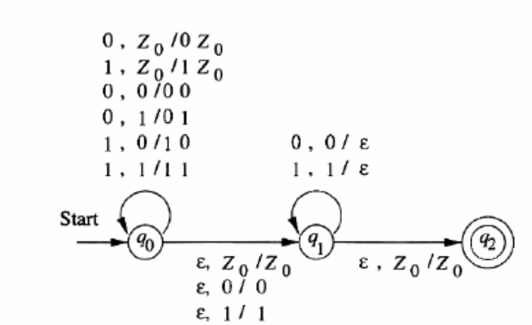
- The arcs correspond to transitions of the PDA in the following sense. An arc labeled a, x/ γ from state q to state p means that s(q,a,x) contains the pair(p, γ) perhaps among other pairs. That is the arc labeled tells what input is used and also gives the old and new tops of the stack.

The only thing that use Left us is which stack symbol is the start symbol. Conventionally, it is Z₀, unless we indicate otherwise. Thus it shows the graphical representation of PDA.

Instantaneous description of a PDA:

The PDA goes from configuration to configuration, in response to the input symbols (or)times ε,but unlike the finite the state is the only thing that we need to know about the automation, the pdas configuration of a pda by a triple (q,w,γ), where
- q is the state
- w is the remaining input and
- γ is the stack contents.
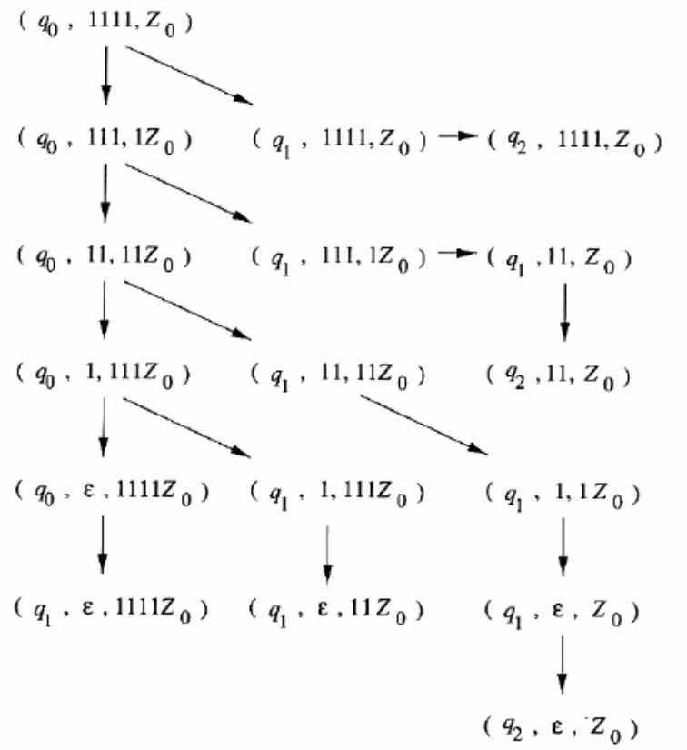

Example
Let us consider the action of the PDA of example above on the input 1111. Since q0 is the start state and z0 is the start symbol, the initial ID is (q0,1111,z0). On this input PDA has an opportunity of guess wrongly several times. The entire sequence of ID’s that the PDA can reach from the initial Id(q0,1111,z0) as shown below.

Explain the languages of PDA? (or)
Give a brief note on languages of PDA? (10 Marks)

The PDA accepts its input by consuming it and entering an accepting state. We call this approach “acceptance by final start”. There is a second approach to defining for any PDA the language “acceptance by empty stack” that is the set of strings that cause the PDA to empty its stack starting from the initial string.

Acceptance of Final State
Let p=(Q, Σ, ⎡, δ, q₀, z₀, F) be a PDA. Then L(p), the language accepted by p by final state is

{w | (q₀, w, z₀) (q, ε, α) }

That is, starting in the initial string w waiting on the input, p consumes w from the input and enters and accepting state. The content of the stack at the time is irrelevant.

Acceptance by Empty Stack
For each PDA p=(Q, Σ, ⎡, δ, q₀, z₀, F).We also define

{w | (q₀, w, z₀) (q, ε, ε) }

For any state q. That is N(P) is the set of input w that P can consume and at the same time empty its stack.
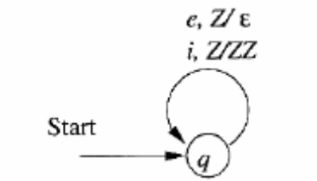
From Empty Stack To Final State
With the PDA diagram we have to add one final state.

Ex: Let us design a PDA that process sequence of if’s and else’s in a C program, where i stands for if and e stands for else. We shall use a stack symbol Z to count the difference between the numbers of its seen so far, and the number of e’s. This simple one state PDA is suggested by the transition diagram as follows.

The PDA is defined as, P_{N} = { {q},{i,e},{Z}, δ_{n}, q, Z)
The above PDA can be changed as follows to accept the string by reaching the final state.
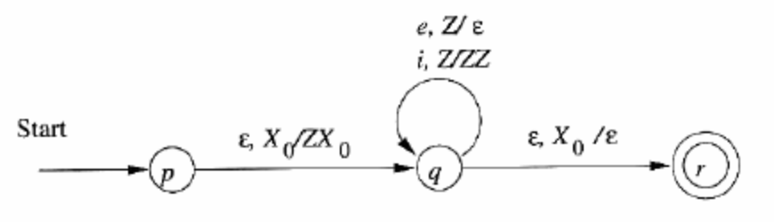
Final State to Empty Stack
From each accepting state we have to add one more transition to a new non-accepting state.

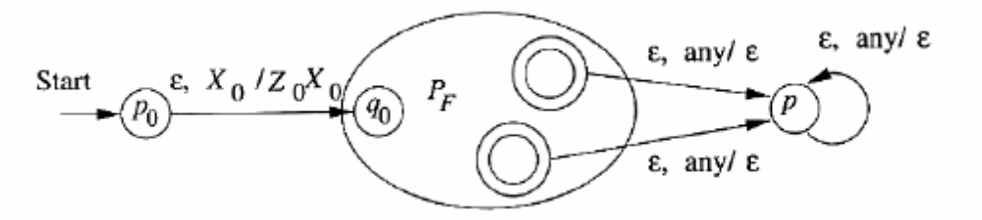

Explain the equivalence of PDA’S and CFG’S? (or)
Write the similarities between PDA’S and CFG’S? (10 Marks)

The languages defined by PDA’s are exactly the context free languages. The goal is to prove that the following three classes of languages.
- The context free languages, that is the languages defined by CFG’s
- The languages that are accepted by final state by some PDA.
- The languages that are accepted by empty stack by some PDA.
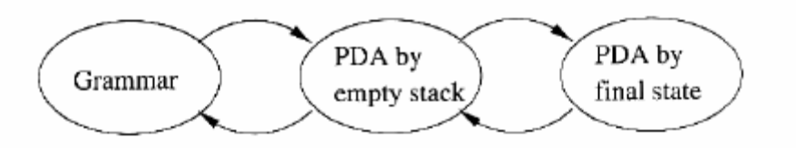

From Grammars to Pushdown Automata

Given a CFG G, we construct a PDA that simulates the leftmost derivations of G. Any left-sentential form that is not a terminal string can be written as xAα, where A is the leftmost variable, x is whatever terminals appear to its left and α is the string of terminals and variables that appear to the right of A. We call Aα the tail of the left sentential form. If a left sentential form consists of terminals only, then its tail is ε.

The idea behind the construction of a PDA form a grammar is to have the PDA simulate the sequence of left sentential forms that the grammar uses to generate a given terminal string w. The trail of each sentential form xAα appears on the stack, with A at the top. At that time, x will be “represented” by our having consumed x from the input, leaving whatever of w follows its prefix x. That is if w = xy, then y will remain on the input.

Suppose the PDA is in an ID(q,y,Aα), representing left sentential form xAα. It guesses the production to use to expand A, say A→β. The move of the PDA us to replace A on the top of the stack by β, entering ID(q,y,βα). Note that there is only one state q, for this PDA.

Now (q,y,βα) may not be a representation of the next left-most form, because β may has a prefix of terminals . In fact β may have no variable at all, and α may have a prefix of terminals. Whatever terminals appear at the beginning of βα need to be removed, to expose the next variables ate the top of the stack. These terminals are compared against the next input symbols, to make sure our guesses at the leftmost derivation of input string w are correct, if not, this branch of the PDA dies derivation of w, then we shall eventually reach the left-sentential form w. At that point, all the symbols on the stack have either been expanded or matched against the input. The stack is empty and we accept by empty stack.

Let G=(V,T,Q,S) be a CFG. Construct the PDA p that accepts; L(G) by empty stack as follows.
P=({q},T, V ∪ T , δ ,q ,s)
Where transition function δ is defined by
- For each variable A, δ (q, ε, A)= {(q, β)/A → β is a production of P}.
- For each terminal a , δ (q,a,a)={(q, ε)}

Example: Let us convert the expression grammar to PDA . The grammar is
I → a | b | Ia | Ib | I0 | I1
E → I | E*E | E+E | (E)
The set of terminals for the PDA is {a,b,0,1(,),+*}. The 8 symbols and the symbols I and E form the stack alphabet. The transition function for the PDA is:
- δ(q, ε, I) ={ (q,a), (q,b), (q,Ia), (qIb), (q,I0), (q,I1) }
- δ(q, ε, E) = { (q, I), (q,E+E), (q,E*E),(q,(E)) }
- δ(q,a,a)={(q,ε)}; δ(q,b,b)={(q,ε)}; δ(q,0,0)={(q,ε)};
- δ(q,1,1)={(q,ε)}; δ (q,(,()={(q,ε)}; δ (q,),))={(q,ε)};
- δ(q,+,+)={(q,ε)}; δ (q,*,*)={(q,E)};
From PDA to grammar:

A PDA may change state as it pops stack symbols, so we should also note the state that it enters when if finally pops a level off its stack.

Give a brief note on Deterministic Pushdown Automata (DPDA)? (10 Marks)
Discuss DPDA based on regular expression, context free languages, and ambiguous grammar?

A PDA is deterministic if there is never a choice of move in any situation. These choices are of two kinds, of δ(q,a,X) contains more than one pair, then surely the PDA is nondeterministic because we can choose among these pairs when decidedly on the next move. However even if δ (q,a,x) is always a singleton, we could still have a choice between using a real input symbol, or making a row on ε . Thus we define a PDA p=(Q,∑,Г,δ,q0,Z₀,F) to be deterministic , if and only if the following conditions are met.
- δ(q,a,x) has at most one member for any q in Q, a in ∑ or a=ε, and x in Г.
- If δ(q,a,x) is non empty, for some a in ∑, then δ(q,ε,x) must be empty.

Example: The language L_{wwr} that has no DPDA. If we put a center-marker ‘c’ in the middle, we can make the language recognizable by a DPDA.

The strategy of the DPDA is to store 0’s and 1’s on its stack, until it sees the context markers c. If then goes to another state, in which it matches input symbols against stack symbols and pops the stack if they match. If it ever finds a non match it dies, its input cannot be of the form wcw^{R}. If it succeeds in popping its stack down to the initial symbol, which marks the bottom of the stack, then it accepts its input.

The PDA is non deterministic, because on state q0, it always has the choice of pushing the next input symbol onto the stack or making a transition on ε to state q1; ie., it has to guess when it has reached the middle . The DPDA for L_{wcwr} is shown in the following figure.
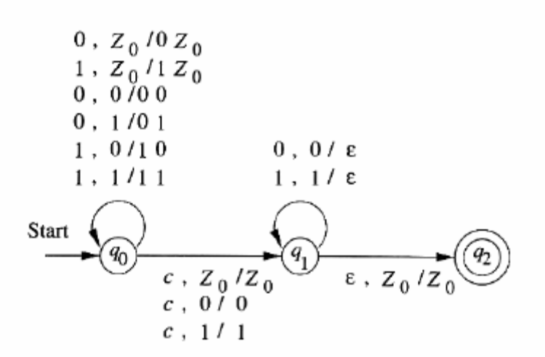

This PDA is clearly deterministic. It never has a choice of move in the same state, using the same input and stack symbol. As for choices between using a real input symbol or ε, the ε-transition it makes is from q1 to q2 with Z₀ at the top of the stack. However, in state q1, there are no other moves when Z₀ is at the stack top.

Regular Languages and Deterministic PDA’S:

The DPDA’s accept a class of languages that is between the regular languages and the CFL’s. We shall first prove that he DPDA language include all the regular languages. If we want the DPDA to accept by empty stack, then we find that our language recognizing capability is rather limited. Say that language L has the prefix property if there are no two different strings x and y in L such that x is a prefix of y.

Example: That is , it is not possible for there to be two strings wcw^{R} and xcx^{R}, one of which is a prefix of the other, unless they are the same string. To see why suppose wcw^{R} is a prefix of xcx^{R}, and w≠x. Then w must be shorter than x. Therefore the c in wcw^{R} comes in position where xcx^{R} has a 0 or 1; it is a position in the first x. That point ultraist the assumption that wcw^{R} is a prefix of xcx^{R}.

On the other hand, there are some very simple languages that do not have the prefix property. Consider {0}*, that is the set of all string of 0’s. Clearly there are pairs of strings in this language one of which is a prefix of the other. So this language does not have a prefix property. In fact of any two strings, one is a prefix of the other, although the condition is stronger than we need to establish that the prefix property does not hold.

DPDA’S and Context Free Languages:

To see the language L_{wcwr} is not regular, suppose it were and use the pumping lemma. If n is a constant of the pumping lemma, then consider the string w=0^{n}c0^{n}, which is in L_{wcwr.} When we pump this string, it is the first group of 0’s whose length must change, so we get in L_{wcwr} strings that have the “center” marker not in the center. Since these strings are not in L_{wcwr} we have a contradiction and conclude that L_{wcwr} is not regular.
On the other hand, there are CFL’s like L_{wcwr} that cannot be L(P) for any DPDA P. A formal proof is complex, but the intuition is transparent. If P is a DPDA accepting L_{wcwr,} then given a sequence of 0’s, it must store them on the stack, or do something to count the arbitrary number of 0’s.

Suppose p has seen n 0’s and the sees 110^{n}. It must verify that there were n 0’s after the 11, and to do so it must pop its stack. Now P has seen 0^{n}110^{n}. If it sees the identical string next, it must accept, because the complete input is of the form ww^{R}, with W=0^{n}110^{n}. However if it sees 0^{m}110^{m} for some m≠n, P must not accept. Since its stack is empty, it cannot remember what arbitrary integer n was, and must fail to recognize L_{wcwr} correctly, our conclusion is that:

The languages accepted by DPDA’s by final state properly include the regular languages, but are properly included in the CFL’s.

 End of Unit -3 

U N I T - IV
Explain about the Turing machines? (or)
What is Turing Machine? Explain its Components. (10 marks)

A problem that can’t be solved by computer is called as “undecidable” problems. Those problems can be solved using a new computing device called the Turing Machine.

Notation for the Turing Machine
The Turing machine consists of a finite control which can be in any of a finite set of states. There is a tape divided into squares or cells; each cell can hold any one of a finite number of symbols.

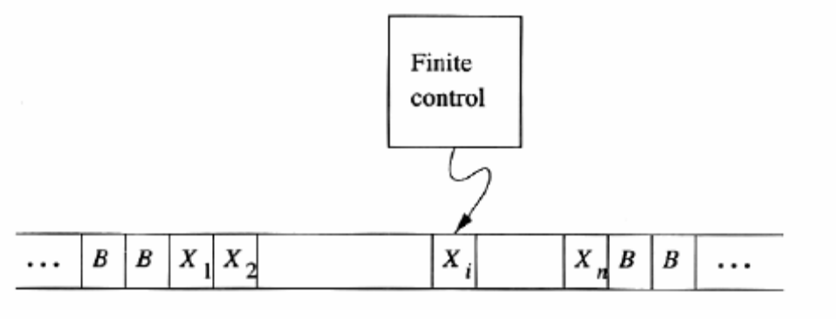
A Turing machine

- Initially, the input string of symbols chosen from the input alphabet is placed on the tape.
- All other tape cells initially hold a special symbol called the blank.
- The blank is a tape symbol, but not an input symbol.
- There is a tape head that is always positioned at one of the tape cells.
- The Turing machine is said to be scanning that cell.
- Initially the tape head is at the leftmost cell that holds the inputs.
- A move of the TM is a function of the state of the finite control and the tape symbol scanned.
- In one move, the Turing machine will:
- Change state. The next state optionally may be the same as the current state.
- Write a tape symbol in the cell scanned.
- Move the tape head left or right.
The formal notation we shall use for a Turing machine(TM) is similar to that used for finite automata or PDA’s . We describe a TM by the 7-tuple
M = (Q, Σ, ⎡, δ, q_{0,} B, F)
Whose components have the following meanings:
Q The finite set of state of the finite control.
Σ The finite set of input symbols.
⎡ The complete set of tape symbols.
δ The transition function. The value of δ(q, X) if it is defined, is a triple (p, Y, D), where :
p is the next state in Q, Y is the symbol, in ⎡, D is a direction, either “left” or “right”.
q₀ The start state, a member of Q, in which the finite control is found initially.
B The blank symbol.
F The set of finite or accepting state, a subset of Q.
Instantaneous Descriptions
The string X₁ X₂ ….X_{i-1} q X_{i} X_{i+1} .. X_{n} is used to describe the transition in Turing machines
- q is the state of the Turing machine.
- The tape head is scanning the i^{th} symbol from the left.
- X₁X₂..X_{n} is the portion of the tape between the leftmost and the rightmost nonblank.
- The moves of the Turing machine are described by notation. And, or will be used to indicate zero, one, or more moves of the TM.

Example:
Let us design a Turing machine will accept the language {0^{n}1^{n} | n>=1}. Initially, it is given a finite sequence of 0’s and 1’s on its tape, preceded and followed by infinity of blanks. Alternately, the TM will change a 0 to an X and then a 1 to a Y, until all 0’s and 1’s have been matched.

In more details, starting at the left end of the input, it repeatedly changes a 0 to an X and moves to the right over whatever 0’s and Y’s it sees, until it comes to a 1.It changes the 1 to a Y, and moves left, over Y’s and 0’s , until it finds an X. At that point, it looks for a 0 immediately to the right, and if it finds one, changing it to X and repeats the process, changing a matching 1 to a Y.

The formal specification of the TM is M=({q₀,q₁,q₂,q₃,q₄},{0,1},{0,1,X,Y,B}, δ, q0, B, {q4}), Where δ is given by the table in figure
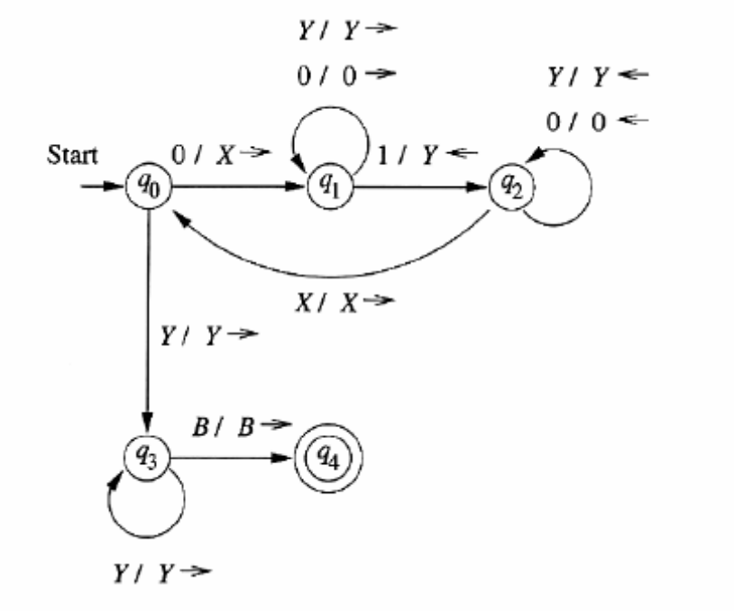
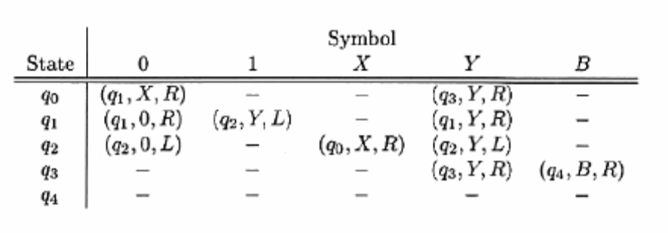

Transition Diagrams

A transition diagrams consists of a set of nodes corresponding to the states of the TM. An arc from state q to state p is labeled by one or more items of the form X / Y D, where X and Y are tape symbols, and D is a direction, either L or R. Start state is represented by the word “start” and an arrow entering that state. Accepting states indicated by double circles. This, the only information about the TM one cannot read directly from the diagram is the symbol used for the blank. We shall assume that symbol is B unless we state otherwise. The transition diagram for the previous example is given below.

Example
In this example we shall show how a Turing machine might compute the function ⎯ ,which is called minus or proper subtraction and is defined by m ⎯ n =max(m-n,0) that is m ⎯ n is m-n if m ≥ n and 0 if m<n.

A TM that performs this operation is specified by
M=({q_{0,}q₁,…….q₆},{0,1},{0,1,B},δ,q₀,B)
Note that, since this TM is not used to accept inputs, we have omitted the seventh component, which is the set of accepting states. M will start with a tape consisting of 0^{m} 10^{n} surrounded by blanks. M halts with 0^{m-n} on its tape, M repeatedly finds its leftmost remaining 0 and replaces it by a blank. It then searches right, looking for a 1. After finding a 1, it continues right, until it comes to a 0, which it replaces by a 1. M then returns left, seeking the leftmost 0, which it identifies when it first meets a blank and then moves one cell to the right. The repetition ends if either:
- Searching right for a 0, M encounters a blank. Then the n 0’s in 0m 10^{n} have all been changed to 1’s and m+1 of the m 0’s have been changed to B. M replaces the n+1 1’s by one 0 and n B’s leaving m-n 0’s on the tape. Since m>=n in this case, m-n=m-n.
- Beginning the cycle, M cannot find a 0 to change to a blank, because the first m 0’s already have been changed to B. Then n>=m, so m-n=0. M replaces all remaining 1’s and 0’s by B and ends with a completely blank tape.
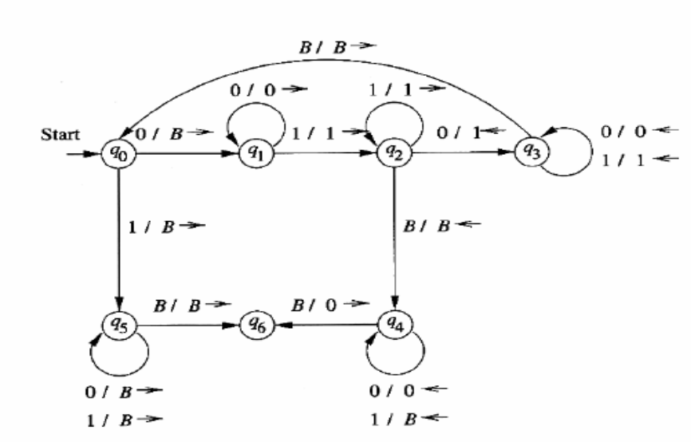
The following fig shows the rules of the transition function δ and we have also represented δ as a transition diagram.

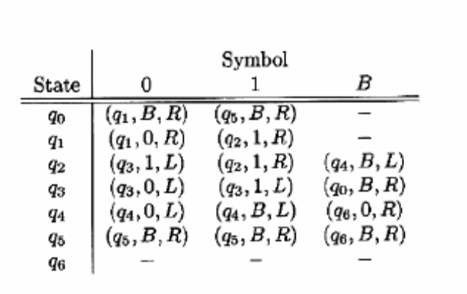

The following is a summary of the role played by each of the seven states:
q₀ This state begins the cycle, and also breaks the cycle when appropriate. If M is scanning a 0, the cycle must repeat. The 0 is replaced by B the scanning B, then all possible matches between the two groups of 0’s on the tape have been made, and M goes to state q₅ to make the tape blank.
q₁ In this state, M searches right, through the initial block of 0’s looking for the leftmost when found, M goes to state q2.
q₂ M moves right, skipping over 1’s until it finds a 0. It changes that 0 to a 1, turns leftward, and enters state. However it is also possible that there are no more 0’s left after the block of 1’s.
q₃ M moves left, skipping over 0’s and 1’s until it finds a blank. When it finds B, it moves right and returns to state q₀ , beginning the cycle again.
q₄ Here, the subtraction is complete, but one unmatched 0 in the first block was incorrectly changed to a B. M therefore moves left, changing 1’s to B’s until it encounters a B on the tape. It changes that B back to 0, and enters state q₆ wherein M halts.
q₅ State q₅ is entered from q₀ when it is found that all 0’s in the first block have been changed to B. In this case, described in (2) above, the result of the proper subtractions is 0. M changes all remaini8ng 0’s and 1’s to B and enters state q₆.
q₆ The sole purpose of this state is to allow M to halt when it has finished its task. If the subtraction had been a subroutine of some more complex function, then q6 would initiate the next step of that larger computation.

Language of Turing machine and its Halting

The input string is placed on the tape, and the tape head begins at the leftmost input symbol. If the TM eventually enters an accepting state, then the input is accepted, and otherwise not. Let M = (Q, Σ,δ₀ ,B,F) be a Turing machine. Then L(M) is the set of strings w in such that for some state p in F and any tape strings α and β. This definition was assumed when we discussed the Turing machine of
Example which accepts strings of the form 0^{n} 1^{n}. The set of languages we can accept using a Turing machine is often called the recursively enumerable languages or RE languages.

There is another notation of “acceptance” that is commonly used for Turing machines acceptance by halting. We say a TM halts if it enters a state q, scanning a tape symbol x, and there is no move in this situation. i.e., δ(q,X) is undefined.

Give short notes on Programming Techniques for Turing Machines. (or)
Explain the Programming Techniques involved in Turing Machines. (10 Marks)
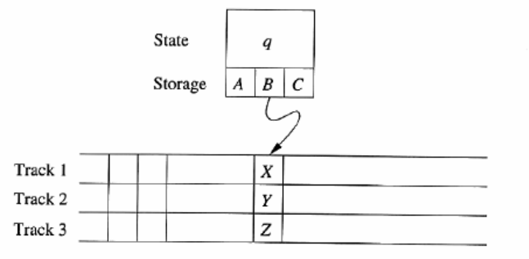
The ability of a TM is denoted by
- Storage in the State
- Multiple tracks
- Subroutines

Storage in the State

The finite control is used not only to represent a position in the “program” of the Turing machine, but to hold a finite amount of data. Here we see the finite control consisting of not only a “control” state q but three data elements A, B, and C. The technique requires no extension to the TM model and is considered as a tuple. We shall design a TM
M=(Q,{0,1},{0,1,B},δ,[q₀,B],{[q₁,B]})
That remembers in its finite control the first symbol that it sees, and checks that it does not appear elsewhere on its input. Thus, M accepts the language 01*+10*. Accepting regular languages such as this one does not stress the ability of Turing machines but it will serve as a simple demonstration.
The set of states Q is {q₀,q₁}× {0,1,B}. T at is the states may be thought of as pairs with two components.
- A control portion q₀ or q₁ that remembers what the TM is doing control state q₀ indicates that M has not yet read its first symbol while q1 indicates that it has read the symbol, and is checking that it does not appear elsewhere by moving right and hoping to reach a blank cell.
- A data portion ,which remembers the first symbol seen, Which means be 0 the transition function δ of M is as follows:
- δ([q_{0,B}],a)=([q₁,a],a,R) for a=0 or a=1. Initially, q₀ is the control state ,and the data portio0n the is B., the symbol scanned is copied into the copied into the second component of the state, and M moves right, entering control state q₁ as it does so.
- δ(q₁,a],a) = ([q₁,a],a,R) where a is the “complement” of a, that is, 0 if a=1 and 1 if a=0. In state q1, M skips over each symbol 0 or 1 that is different from the one it has stored in its state, and continuous moving right.
- δ([q₁,a],B) =([q₁ B],B,R) for a=0 or a=1. If M reaches the first blank, it enters the accepting state[q_{1,}B].

Multiple Tracks

Turing machine consists of several tracks. Each track can hold one symbol, and the tape alphabet of the TM consists of tuples, with one component for each “track”. A common use of multiple tracks is to treat one track as holding the data and a second track as holding a mark. In the present example, we shall use a second track explicitly to recognize the non-context-free language
L_{wcw} ={wcw | w is in (0+1)⁺}
The Turing machine we shall design is:

M=(Q, ∑, Γ, δ, [q1,B], [B,B], {[q9,B]})
Where:
Q The set of states is {q1,q2,……q9}×{0,1} that is pairs consisting of a control state q_{i} and a data component 0 or 1.
Γ The set of tape symbols is {B,*}×{0,1,c,B). The first component or track can be either blank or checked represented by the symbols B and * respectively
∑ The input symbols are [B,0] and [B,1] identified with 0 and 1 respectively.
δ The transition function δ.

Subroutines

A Turing machine subroutine is a set of states that perform some useful process. This set of states includes a start state and another state that temporarily has no moves, and that serves as the “return” state to pass control to whatever other set of sates called the subroutine. The “call” of a subroutine occurs whenever there is a transition to its initial state. Since the TM has no mechanism for remembering a “return address”, that is, a state to go to after it finishes, should our design of a TM call for one subroutine to be called from several states, we can make copies of the subroutine, using a new set of states for each copy. The “calls” are made to the start states of different copies of the subroutine, and each copy “returns” to a different state.

Example: We shall design a TM to implement the function “multiplication”. That is, our TM will start with 0^{m} 10^{n} on its tape, and will end with 0^{mn} on the tape. An outline of the strategy is:
- The tape will in general have one nonblank string of the form 0^{i} 10^{n} 10^{kn} for some k.
- In one basic step, we change a 0 in the first group to B and add n 0’s to the last group, giving us a string of the form 0^{i-1} 10^{n}10^{(k+1)n} .
- As a result, we copy the group of n 0’s to the end m times, once each time we change a 0 in the first group to B. When the first group of 0’s completely changed to blanks, there will be mn 0’s in the last group.
- The final step is to change the leading 10^{n} 1 to blanks, and we are done.

The heart of this algorithm is a subroutine, which we call copy. This subroutine implements step (2) above copying the block of n 0’s to the end. Copy converts an ID of the form 0^{m-k} 1q₁0^{n}10^{(k-1)n} to ID 0^{m-k}1q₅0^{n}10^{kn} . The following figure shows the transitions of subroutine copy.
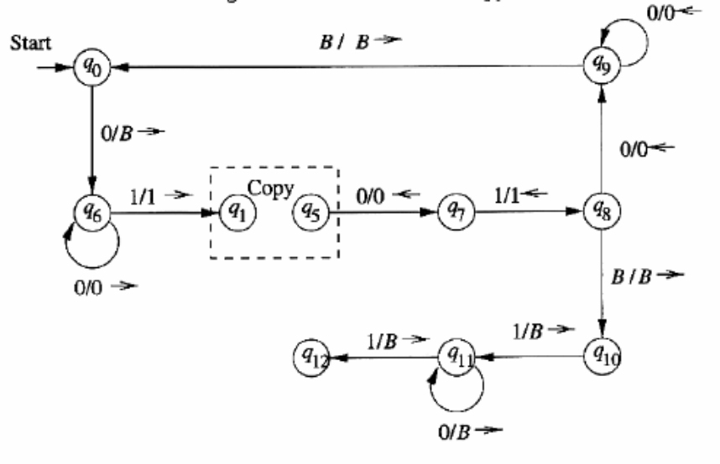
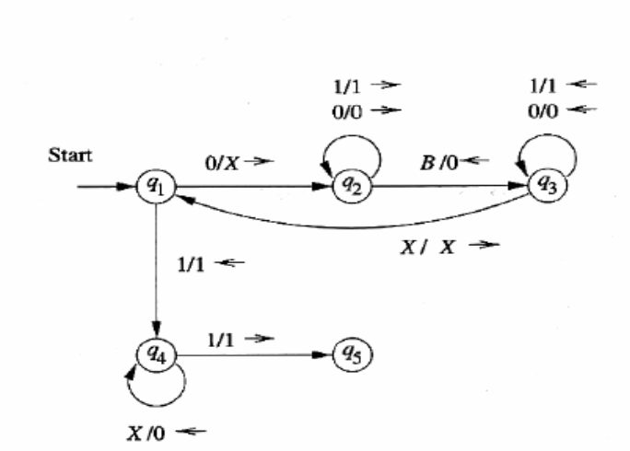

- This subroutine marks the first 0 with an X, moves right in state q₂ until it finds a blank, copies the 0 there, and moves left in state q₃ to find the marker X.
- It repeats this cycle until in state q1 it finds a 1 instead of a 0. At that point, it uses state q₄ to change the X’s back to 0’s and ends inn state q₅.
- The complete multiplication Turing machine starts in state q₀. The first thing it does is go, in several steps, from ID qo0^{m}10^{n} to ID 0^{m-1}1q₁0^{n}1. The transitions needed are shown in the portion of figure to the left of the subroutine call; these transitions involve states q₀ and q₆ only.
- The purpose of state q7,q8 and q9 is to take control after copy has just cop8ied a block of n 0’s and is in ID 0^{m-k} 10^{n} 10^{kn} . Eventually, these states bring us to state q₀om-k10^{n}.
- At that point the cycle starts again and copy is called to copy the block of n 0’s again. As an exception in state q8 the TM may find that all m 0’s have been changed to blanks.
- In that case, a transition to state q₁₀ occurs. This state, with the help of state q₁₁, changes the leading 10^{n}1 to blanks and enters the halting state q₁₂.
- At this point, the TM is in ID q₁₂ 0^{mn} and its job is done.

Write short notes on Extensions to the Basic Turing Machine. (or)
Explain the various models of Basic Turing Machine. (10 Marks)

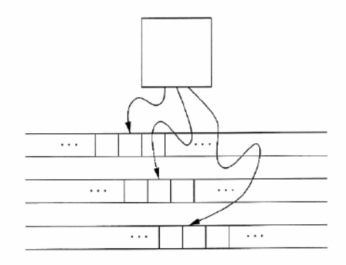
Nondeterministic Turing machine, an extension of the basic model that is allowed to make any of a finite set of choices of move in a given situation. This extension also makes “programming” Turing machines easier, but adds no language-defining power to the basic model.

Multitape Turing Machines
The device has a finite control and some finite number of tapes. Each tape is divided into cells, and each cell can hold any symbol of the finite tape alphabet. As in the single tape TM, the set of tape symbols includes a blank, and has a subset called the input symbols, of which the blank is not a member. The set of states includes an initial state and some accepting states. Initially:
- The input, a finite sequence of input symbols is placed on the first tape.
- All other cells of all the tapes hold the blank.
- The finite control is in the initial state.
- The head of the first tape is at the left end of the input.
- All other tape heads are at some arbitrary cell.
A move of the multitape TM depends on the state and the symbol scanned by each of the tape heads. In one move the multitape TM does the following:
- The control enters a new state, which could be the same as the previous state.
- On each tape, a new tape symbol is written on the cell scanned. Any of these symbols may be the same as the symbol previously there.
- Each of the tape heads makes a move, which can be left, right or stationary. The heads move independently, so different heads may move in different directions, and some may not move at all.
Multitape Turing machines like one-tape TM’s accept by entering an accepting state.

Equivalence of One-Tape and Multitape TM’s

Recursively enumerable languages are defined to be those accepted by a one-tape TM. Multitape TM’s accept all the recursively enumerable languages, since a one tape TM is multitape TM.

Running Time and the Many-Tapes-to-one Construction

The running time of TM M on input w is the number of steps that M makes before halting. If M doesn’t halt on w, then the running time of M on w is infinite. The time complexity of TM M is the function T(n) that is the maximum over all inputs w of length n, of the running time of M on w. For Turing machines that do not halt on all inputs T(n) may be infinite for some or even all n.

The constructed one tape TM may take much more running time than the multi9tape TM. However, the amounts of time taken by the two Turing machines are commensurate in a weak sense: the one-tape TM takes time that is no more than the square of the time taken by the other. While “squaring” is not a very strong guarantee, it does preserve polynomial running time.

- The difference between polynomial time and higher growth rates in running time is really the divide between what we can solve by computer and what is in practice not solvable.
- Despite extensive research, the running time needed to solve many problem has not been resolved closer than to within the same polynomial

Nondeterministic Turing Machines

A nondeterministic Turing machine differs from the deterministic variety we have been studying by having a transition function such that for each state q and tape symbol x, δ(q,X) is a set of triples
{(q1,Y1,D1),(q2,Y2,D2,),….,(q_{k,},Y_{k},D)}where k is any finite integer.

The language accepted by an NTM M is defined in the expected manner, in analogy with the other nondeterministic devices, such as N FA’s and PDA’s that we have studied. That is M accepts an input w if there is any sequence of choices of move that leads from the initial ID with w as input, to an ID with an accepting state.

The NTM’s accept no languages not accepted by a deterministic TM. The proof involves showing that for every NTM M_{N} we can construct a DTM M_{D} that explores the ID’s that MN can reach by any sequence of its choices.If M_{D} finds one that has an accepting state, then M_{D} enters an accepting state of its own. M_{D} must be systematic, putting new ID’s on a queue rather than a stack, so that after some finite time M_{D} has simulated all sequences up to moves of M_{N} for k=1,2,….

Explain Restricted Turing Machines with example. (or)
Give a brief note on Restricted Turing Machines with example. (10 Marks)

First, we restrict the tapes of the TM to behave like stacks. Then, we further restrict the tapes to be “counters” that is, they can only represent one integer, and the TM can only distinguish a count of 0 from any nonzero count.

Turing Machines with Semi-infinite Tapes
We can assume the tape is semi-infinite that is there are no cells to the left of the initial head position. In the next theorem, we shall give a construction that shows a TM with a semi-infinite tape can simulate one whose tape is, like our original TM model, infinite in both directions.

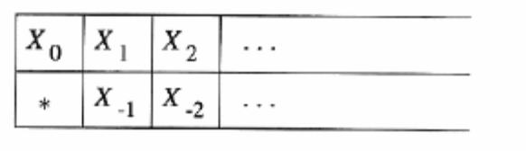
The trick behind the construction is to use two tracks on the semi-infinite tape. The upper track represents the cells of the original TM that are at or to the right of the initial head position. The lower track represents the positions but in reverse order. The exact arrangement is suggested in figure.

The upper track represents cells X,X,….,where X₀ is the initial position of the head X₁,X₂, and so on, are the cells to right. Cells X-1,X-2 and so on. Represent cells to the left of the initial position. End marker and prevents the head of the semi-infinite TM from accidentally falling off the left end of the tape.
We can make one more restriction to our Turing machine it never writes a blank. This simple restriction, coupled with the restriction that the tape is only semi-infinite means that the tape is at all times a prefix of nonblank symbols followed by infinity of blanks. Further, the sequence of non blanks always begins at the initial tape position.

Multi stack machine
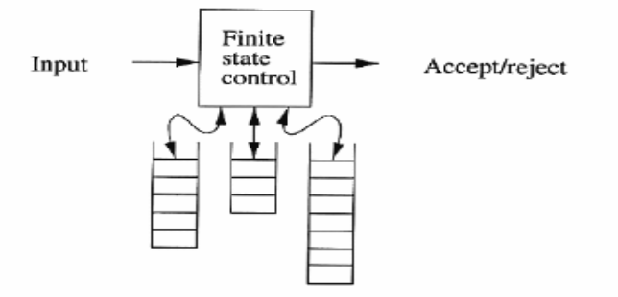
We now consider a class of machines called “counter machines.” These machines have only the ability to store a finite number of integers (“counter”), and to make different moves depending on which if any of the counters are currently 0. The counter machine can only add or subtract one from the counter, and cannot tell two different nonzero counts from each other in effect, a counter is like a stack on which we can place only two symbols: a bottom-of-stack marker that appears only at the bottom and one other symbol that may be pushed and popped from the stack.

A k-stack machine is a deterministic PDA with k stacks. It obtains its input, like the PDA does, from an input source, rather than having the input placed on tape or stack, as the TM does. The multi stack machine has a finite control, which is in one of a finite set of states. It has a finite stack alphabet, which it uses for all its stacks. A move of the multi stack machine is based on:
- The state of the finite control.
- The input symbol read, which is chosen from the finite input alphabet. Alternatively, the multi stack machine can make a move using ε input, but to make the machine deterministic, there cannot be a choice of an ε-move or a non-ε-move in any situation.
- The top stack symbol on each of its stacks.
In one move, the multistack machine can:
- Change to a new state.
- Replace the top symbol of each stack with a string of zero or more stack symbols. There can be ( and usually is ) a different replacement string for each stack.
Thus, a typical transition rule for a k-stack machine looks like:
δ(q,a,X1,X2…X_{k})=(p,Y1,Y2……,Y_{k})
The interpretation of the rule is that state q, with X_{i} on top of the i^{th} stack, for i=1,2….,k, the machine may consume a (either an input symbol or Є ) from is input, go to state p, and replace X_{i} on top of the i^{th} stack by string Y_{i} for each i=1,2,…,k. The multistack machine accepts by entering a final state.

We add one capability that simplifies input processing by this deterministic machine: we assume there is a special symbol $, called the end-marker that appears only at the end of the input and is not part of that input. The presence of the end marker allows us to know when we have consumed all the available input, we shall see in the next theorem how the end marker makes it easy for the multistack machine to simulate a Turing machine. Notice that the conventional TM needs no special end marker, because the first blank serves to mark the end of the input.

Counter Machines

A counter machine may be thought of in on of two ways:
- The counter machine has the same structure as the multistack machine, but in place of each stack is a counter. Counters hold any nonnegative integer, but we can only distinguish between zero and nonzero counters. That is, the move of the counter machine depends on its states, input symbol, and which, if any, of the counters are zero. In one move the counter machine can:
  - Change state.
  - Add or subtract 1 from any of its counters independently. However, a counter is not allowed to become negative, so it cannot subtract 1 from a counter that is currently 0.
- A counter machine may also be regarded as a restricted multistack machine. The restrictions are as follows:
  - There are only tow stack symbols, which we shall refer to as Z₀ (the bottom-of-stack marker), and X.
  - Z₀ is initially on each stack.
  - We may replace Z₀ only by a string of the form X^{i} Z₀ for some i>=0.
  - We may replace X only by X^{i} for some i>=0. That is, Z₀ appears only on the bottom of each stack, and all other stack symbols, if any, are X.
We shall use definition (1) for counter machines, but the two definitions clearly define machines of equivalent power. The reason is that stack X^{i} Z₀ can be identified with the count k. In definition (2), we can tell count 0 from other counts, because for count 0 we see Z₀ on top of the stack, and otherwise we see X.

The Power of Counter Machines

The observations about the languages accepted by counter machines are as follows:
- Every language accepted by a counter machine is recursively enumerable. The reason I so that a counter machine is a special case of a stack machine, and a stack machine is a special case of a multi tape Turing machine, which accepts only recursively enumerable languages.
- Every language accepted by a non-counter machine is a CFL. Note that a counter, in point-of-view (2), is a stack, so a one-counter machine is a special case of one-stack machine, i.e., a PDA. In fact, the languages of one-counter machines are accepted by deterministic PDA’s, although the proof is surprisingly complex. The difficulty in the proof stems from the fact that the multistack and counter machines have an end marker at the end of their input.

Write short notes on Turing machines and computers. (or)
Explain the steps involved in the simulation of Turing machines by computers. (10 Marks)

The claims of TM and computers can be divided into two parts:
- A computer can simulate a Turing machine.
- A Turing machine can simulate a computer, and can do so in an amount of time that is at most some polynomial in the number of steps taken by the computer.

Simulating a Turing Machine by Computer

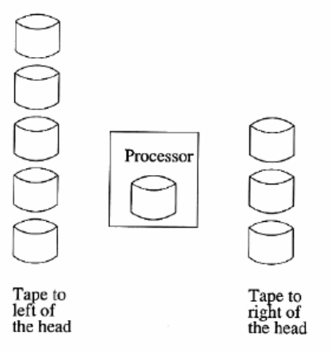
Given a particular TM M, we must write a program that acts like M. one aspect of M is its finite control. Since there are only a finite number of states and a finite number of transition rules, our program can encode states as character strings and use a table of transitions, which it looks up to determine each move. Likewise, the tape symbols can be encoded as character strings of a fixed length, since there are only a finite number of tape symbols. A serious question arises when we consider how out program is to simulate the Turing-machine tape. This tape can grow infinitely long, but the computer’s memory-main memory disk, and other storage devices-are finite.

If there is no opportunity to replace storage devices, then in fact we cannot; a computer would then be a finite automaton, and the only languages it could accept would we regular. However, common computers have swappable storage devices, perhaps a” zip” disk, for example. Since there is no obvious limit on how many disks we could use, let us assume that as many disks as the computer needs is available. We can thus arrange that the disks are placed in two stacks as shown in the figure.

One stack holds the data in cells of the Turing machine tape that are located significantly to the left of the tape of the tape head. And the other stack holds data significantly to the right of the tape head. If the tape head of the TM moves sufficiently far to the left that it reaches cells that are not represented by the disk currently mounted in the computer then it prints a message “swap left” the currently mounted disk is removed by a human operator and placed on the top of the right stack. The disk on top of the left stack is mounted in the computer, and computation resumes.

Similarly, if the TM’s tape head reaches cells so far to the right that these cells are not represented by the mounted disk, then a “swap right” message is printed. The human operator moves the currently mounted disk to the top of the left stack, and mounts the disk on top of the right stack in the computer. If either stack is empty when the computer asks that a disk from that stack be mounted, then the TM has entered an all-blank region of the tape. In that case, the human operator must go toe the store and by a first disk to mount.

Simulating a Computer by a Turing Machine

The following Figure suggests how the Turing machine would be designed would be designed to simulate a computer. This TM uses several tapes, but it could be converted to a one-tape TM using the construction of multi-tape Turing machine
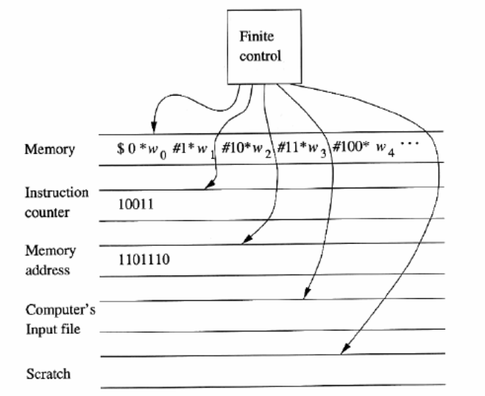
The first tape represents the entire memory of the computer. We have used a code in which addresses of memory words, in numerical order, alternate with the contents are written in binary. The marker symbols * and #are used to make it easy to find the ends of addresses and contents, and to tell whether a binary string is am address or contents.

The second tape is the “instruction counter.” This tape holds one integer in binary, which represents one of the memory locations on tape 1. The value stored in this location will be interpreted as the next computer instruction to be executed.

The third tape holds a “memory address” or the contents of that address after the address has been located on tape 1. To execute an instruction, the TM find the contents of one or more memory addresses that holds data involved in the computation. Our TM will simulate the instruction cycle of the computer, as follows.
- Search the first tape for an address that matches the instruction number on tape 2. We start at the $ on the first tape, and move right, comparing each address with the contents of tape 2.
- When the instruction address is found, examine its value. Let us assume that when a word is an instruction, its first few bits represent the action to be taken (e.g. copy, add, branch), and the remaining bits code an address or addresses.
- If the instruction requires the value of some address copy that address on to the third tape and mark the position of the instruction, using a second track of the first tape.
- Execute the instruction, or the part of the instruction involving the value.
- After performing the instruction, and determining that the instruction is not a jump, add 1 to the instruction counter on tape 2 and begin the instruction cycle again.
The fourth tape holds the simulate input to the computer, since the computer must read its input from a file. A scratch tape is also shown. Simulation of some computer instructions might make effective use of a scratch tape or tapes to compute arithmetic operations such as multiplication. Finally, we assume that the computer makes an output that tells whether or not its input is accepted.

Comparing the Running Times of Computers and Turing Machines
The running time for the Turing machine that simulates a computer are as follows:
- The issue of running time is important because we shall use the TM not only to examine the question of what can be computed at all, but when can be compared with enough efficiency.
- The dividing line between the tractable – that which can be solved efficiently—from the intractable –problems that can be solve, but not fast enough for the solution to be usable –is generally held to be between what can be computed in polynomial time and what requires more than any polynomial running time.
- Thus, we need to assure ourselves that if a problem can be solved in polynomial time on a typical computer, then it can be solved in polynomial time by a Turing machine, and conversely.
Thus the TM described above can simulate n steps of a computer in 0(n³) time, we need to confront the issue of multiplication as a computer instruction.

Explain the informal definition of pushdown automata with example? (or)
Explain PDA with example? (5 marks)

The pushdown automation is a nondeterministic finite automation with ε- transitions permitted and one additional capability, a stack on which it can store a string of “stack symbols”. The PDA can only access the information on its stack in a first in first out way. It recognizes only the context free languages. While there are many languages, that are context free, including some we have seen that are not regular languages, there are also some simple-to-describe languages that are not context free. An example of a non-context free language is{0^{n}1^{n}2^{n} / n ≥1} the set of strings consisting of equal groups of 0’s, 1’s and 2’s.
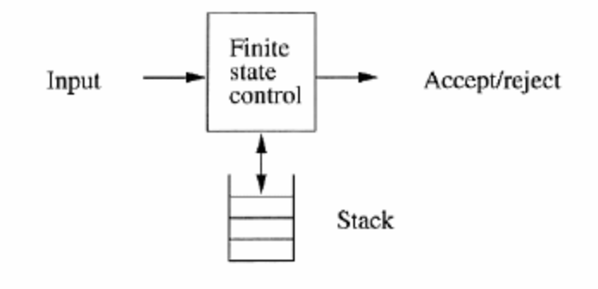

A “finite state control”, reads input, one symbol at a time. The pushdown automation is allowed to observe the symbol at the top of the stack and to base its transition on its current state, the input symbol, and the symbol at the top of the stack. Alternatively, it makes a “spontaneous” transition, using ε as its input instead of an input symbol. In one transition, the pushdown automation
- Consumes from the input the symbol that it uses in the transition. If ε is used for the input then no input symbol is consumed.
- Goes to a new state, which may us may not be the same as the previous state.
- Replace the symbol at the top of the stack by any string. The string could be ε, which Corresponds to a pop of the stack. It could be the same symbol that appeared at the top of the stack previously that is no change to the stack is made.

Example: Let us consider the language L_{wwr} = {ww^{R} | w is in (0+1)*}

This language, often referred to as “w-w-reversed” is the even-length palindromes over alphabet {0,1}.

We can design an informal pushdown automation accepting L_{wwr,} as follows.
- Start in a state q₀ that represents a “guess” that we have not yet seen the middle that is we have not seen the end of the string w that is to be followed by its own reverse.
- While in state q₀, we read symbols and store them on the stack, by pushing a copy of each input symbol on to the stack.
- At anytime, we may guess that we have seen the middle that is the end of w. At this time w will be on the stack with the right end of w at the top and the left end at the bottom. We signify this choice by spontaneously going to state q₁. Since the automation is non deterministic we actually make both guesses. We guess we have seen the end of w, but we also slay in static go and continue to read input and store them on the stack.
- Once in state q₁, we compare input symbols with the symbol at the top of the stack. If they match, we consume the input symbol, pop the stack, and proceed. If they do not match, we have guessed wrong, our guessed w was not followed by w^{R}. This branch dies, although other branches of the non deterministic automation may survive and read to acceptance.
- If we empty the stack, then we have ended seen some input w followed by w^{R}. We accept the output that was read up to this point.

 End of Unit -4 

U N I T - V

Explain the concept of intractability theory based on polynomial time? (or)
Describe the classes P and NP problem using intractability theory? (10 Marks)

We introduce the basic components of intractability theory: the classes P and NP of problems solvable in polynomial time by deterministic and nondeterministic TM’s, respectively, and the technique of polynomial time reduction.

Problems solvable in polynomial time: A Turing machine M is said to be of time complexity T(n) moves, regardless of whether or not M accepts. This definition applies to any function T(n),such as T(n)=50n² or t(n)=3^{n}+5n⁴;we shall be interested predominantly in the case where T(n) is a polynomial in n. we say a language L is in class p if there is some polynomial T(n) such that L=L(M) for some deterministic Tm M of time complexity T(n).

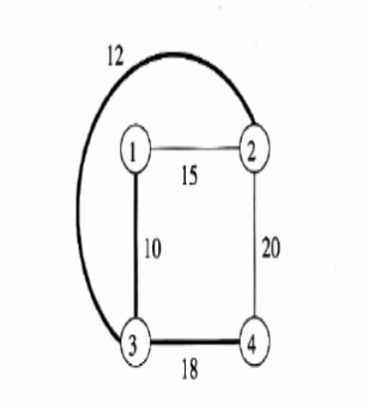
An example: kruskal’s algorithm: Many problems that have efficient solutions; perhaps you studied some in a course on data structures and algorithms. These problems are generally in P. we shall consider one such problem finding there. Informally we think of graphs as diagram such as that of fig

There are nodes, which are numbered 1-4 in this example graph. And there are edges between some pairs of nodes. Each edge has a weight, which is an integer. A spanning tree is a subset of the edges such that all nodes are connected through these edges. Yet there are no cycles. An example of a spanning tree is shown by bold edges. A minimum-weight spanning tree has the least possible total edge weight of all spanning trees.

There is a well-known “greedy” algorithm, called Kruskal’s Algorithm, for finding a MWST. Here is an informal outline of the key ideas:
- Maintain for each node the connected component in which the node appears, using whatever edges of the tree have been selected so far. Initially, no edges are selected, so every node is in it’s a connected component by itself.
- Consider the lowest-weight edge that has not yet been considered; break ties any way you like. If this edge connects two nodes that are currently in different connected components then:
  - Select that edge for the spanning tree, and
  - Merge the two connected components involved.
- Continue considering edges until either all edges have been considered, or the number of edges selected for the spanning tree is one less that the number of nodes. Note that in the latter case, all nodes must be in one connected component and we can stop considering edges.

Example: In the graph we first consider the edge(1:3) because it has the lowest weight, 10. Since 1 and 3 are initially in different components, we accept this edge and make 1 and 3 have the same component number say “component 1”. The next edge in order of weights (2,3), with weight 12, since 2 and 3 are in the different components, we accept this edge and merge node 2 into “component 1”. The third edge is (1,2), with weight 15. However, 1 and 2 are now in the same component, so we reject this edge and proceed to the fourth edge, (3,4). Since 4 is not in “component 1”. We accept this edge, now, we have three edges for the spanning tree of a 4-node graph, and so may stop.
Nondeterministic polynomial time

Formally, we say a language L is in the class NP. if there is a nondeterministic TM and when M is given an input of length n, there are no sequence of more than T(n) moves of M. Our first observation is that, since every deterministic TM is a nondeterministic TM that happens never to have a choice of moves, P ⊆ NP. However, it appears NP contains many problems not in p. The intuitive reason is that a NTM running in polynomial time has the ability to guess an exponential number of possible solutions to a problem and check one in polynomial time, “in parallel”. However it is one of the deepest open questions of Mathematics whether p=NP.Whether in fact everything that can be done in polynomial time by a NTM can in fact are done by DTM in polynomial time, perhaps with a higher-degree polynomial.

The Traveling salesman problem
The input to TSP is the same as to MWST, a graph with integer weights on the edges such as that of fig and a weight limit W. the question asked is whether the graph as a “Hamilton circuit” of total weight at most W. A Hamilton circuit is a set of edges with each node appearing exactly once. Note that the number of edges on a Hamilton circuit must equal the number of nodes in the graph.

Example: The graph of fig actually has only one Hamilton circuit the cycle(1,2,4,3,1). The total weight of the cycle is 15+20+18+10=63. Thus, if W is 63 or more, the answer is “yes”, and if W<63 the answer is “no”.
However, the TSP on four-node graph is deceptively simple, since there can never be more than two different Hamilton circuits once we account for the different nodes at which the same cycle can start, and for the direction in which we traverse the cycle. In m-node graphs, the number of distinct cycles grows as O(m!). the factorial of m, which is more than 2cm for any constant c.
It appears that all ways to solve the TSP involve trying essentially all cycles and computing their total weight. By being clever, we can eliminate some obviously bad choices. But it seems that no matter what we do, we must examine an exponential number of cycles before we can conclude that there is none with the desired weight limit W, or to find one if we are unlucky in the order in which we consider the cycles. On the other hand , if we had a nondeterministic computer, we could guess a permutation of the nodes, and compute the total weight for the cycle of nodes in that order. If there were a real computer that was nondeterministic, no branch
A similar amount of time. Thus, a single –tape NTM can solve the TSP in O (n4) time at most . We conclude that the TSP is in NP.

Polynomial –Time Reductions
Our principal methodology for proving that a problem P2 cannot be solved in polynomial time (i.e. P2 is not in P) is the reduction of a problem P1, which is known, not be in P, to P2.2. the approach was suggested in fig which we reproduce here as
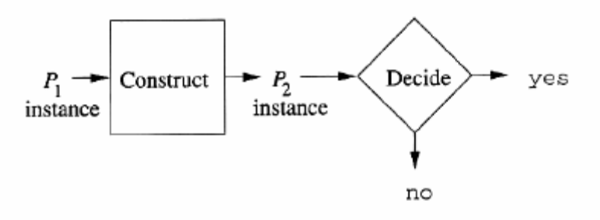
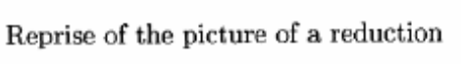
Suppose we want to prove the statement: if P2 is in P, then so is P1”. Since we claim that P1 is not in P, either. However, the mere existence of the algorithm labeled “Construct” in fig 10.2 is not sufficient to prove the desired statement.
For instance, suppose that when given an instance of P1 of length m , the algorithm produced and output string of length 2m, which it fed to the hypothetical polynomial –time algorithm for P2. if that decision algorithm ran in ,, say, time O(n k), then on an input of length 2m it would run in time O(2km), which is exponential in m. Thus, the decision algorithm for Pq takes, when given an input of length m, time that is exponential in m. these facts are entirely consistent with the situation where P2 is in P and P1 is not in P.
Even if the algorithm that constructs a P2 instance from a P2 instance from a P1 instance always produces an instance that is polynomial in the size of its input, we can fail to reach our desired conclusion. For instance, suppose that the instance of P2 constructed is of the same size, m, as the P1 instance, but the construction algorithm for P2 that takes polynomial time O(n_{k}) on input of length n only implies that there is a decision algorithm for P1 that takes time O(2m+mk) on input of length m. this running time bound takes into account the fact that we have to perform the translation to P2 as well as solve the resulting P2 instance. Again it would be possible for P1 to be in P and P2 not.
Thus, in the theory of intractability we shall use polynomial –time reductions only. A reduction from p1 t0 p2 is polynomial –time if it takes time that is some polynomial in the length of ht ep1 instance. Note that as a consequence, the p2 instance will be of a length that is polynomial in the length of the p1 instance.

NP-Complete Problems
Let L be a language (problem) in NP we say L is NP –complete if the following statements are true about L.L is in NP. For every language L1 in NP there is a polynomial-time reduction of D to L.
An example of an NP-complete problem, as we shall see, is the Traveling salesman problem, which we introduced already. Since it appears that P≠NP, and in particular, all the NP-complete problems are in NP-P, we generally view a proof of NP-completeness for a problem as a proof that the problems is not in P.
We shall prove our first problem, called SAT (for Boolean satisfiability) to be NP-complete by showing that the language of every polynomial-time NTM has a polynomial –time reduction to SAT. However, once we have some NP-complete by reducing some known NP=complete problem to it, using a polynomial-time reduction.

Explain an NP-Complete Problem?(or) (10 Marks)
Describe about the NP complete problem?
This problem whether a Boolean expression is satisfiable—is proved NP-complete by explicitly reducing the languages of any nondeterministic, polynomial-time TM to the satisfiability problem.
The satisfiability problem
The Boolean expression is built from:
1. Varibles whose values are Boolean: i.e., they either have the value 1(true)or 0 false.
2. Binary operators Λ and V standing for the logical AND or OR of the two expressions.
3. Unary operator –standing for logical negation.
4. Parentheses to group operators and operands, if necessary at alter the default precedence of operators:-highest, then Λ. and finally v.
Example: An example of a Boolean expression is x Λ-(y vz). The sub expression y v z is true whenever either variable y or variable z has the value true, but the sub expressions is false whenever both y and z are false. The larger sub expression –(y V z) is true exactly when y V z is false, that is , when both y and z are false. If either y or z or both are true, then-(y V z) is false.
Finally, consider the entire expression. Since it is the logical AND of two sub expressions, it is true exactly when both sub expressions are true. That is, x Λ –(y V z) is true exactly when x is true, y is false, and z is false.
A truth assignment for a given Boolean expression E assigns either true or false
to each of the variables mentioned in E. The value of expression E given a truth assignment T, denoted E(t) is the result of evaluation E with each variable x replaced by the value T(x) (true or false) that T assigns to x. A truth assignments T satisfies Boolean expression E if E(T)=1; the truth assignment t makes expression E true A Boolean expression E is said to be satisfiable if there exists at least one truth assignment T that satisfies E.

Representing SAT instance
The symbols in a Boolean expression are Λ,V,- the left and right parentheses, and symbols representing variables. The satisfiability of an expression does not depend on the names of the variables, only on whether two occurrences of variables are the same variables are or different variables. Thus, we may assume that the variables are x1,x2……, although in examples we shall continue to use variable names like y or z, as well as x’ s . we shall also assume that variables renamed as we use the lowest possible subscripts for the variables .
For instance, Since there are an infinite number of symbols that could in principle, appear in a Boolean expression, we have a familiar problem o having to device a code with a fixed, finite alphabet to represent expressions with arbitrarily large number of variables. Only then can we talk about SAT as a “problem”, that is, as a language over a fixed alphabet consisting of the codes for those Boolean expressions that are satisfiable. The code we shall use is as follows.
1. The symbols Λ ,V,¬. (,and) are represented by themselves.
2. The variable xi is represented by the symbol x followed by 0’s and 1’s that represent I in binary.
Thus, the alphabet for the SAT problem/language has only eight symbols. All instances of SAT are strings in this fixed, finite alphabet.
Example consider the expression x Λ ¬(y V z) form example 10.6 our first step in coding it is to replace the variables by subscripted x’s. Since there are three variables. We must use x1, x2,and x3. we have freedom regarding which of x, y , and z is replaced by each of the xi’s and to be specific let x=x1 , y=x2 and z=x2. Then the expression becomes xi Λ ¬ (x2 V x3). The code for this expression is
X1 Λ ¬ ( x 10 V x11)
Notice that the length of a coded Boolean expression is approximately the same as the number of positions in the expression, counting each variable be current as i. the reason for the difference is a that if the expression has m position it can have O(m) variables, so variables may take O(log m) symbols to code. Thus, an expression whose length is m positions can have a code as long as n=O(m log m) symbols.
However, the difference between m and m log m is surely limited by a polynomial. Thus, as long as we only deal with the issue of whether or not a problem can be solved in time that is polynomial in its input length, there is no need to distinguish between the length of an expression’s code and the number of positions in the expression itself.

NP-Completeness of the SAT problem
We now prove “cook’s Theorem”, the fact that SAT is NP-complete. To prove a problem is NP-complete, we need first to show that it is in NP. Then, we must show that every language in NP reduces to the problem in question. In general, we show the second part by offering a polynomial – time reduction from some other NP-complete problem at right now; we don’t know any NP-complete problems to reduce to SAT. Thus, the only strategy available is to reduce absolutely every problem in NP to Sat.

Explain the Complements of Languages in NP? (or) ( 10 Marks)
Write short notes on the complements of languages in NP?

The class of languages P is closed under complementation for a simple argument why, let L be in P and let M be a TM for L. Modify M as follows, to accept L. Introduce a new accepting state q and have the new TM transition to q whenever M halts in a state that is not accepting. Make the former accepting states of M be non accepting. Then the modified TM accepts L, and runs in the same amount of time that M does, with the possible addition of one move. Thus, L is in P if L is.
It is not known whether NP is closed under complementation. It appears not, however, and in particular we expect that whenever a language L is NP complete, then its complement is not in NP.

The Class of Languages Co-NP
Co-NP is the set of languages whose complements are in NP. We observed at the beginning of section that every language in P has its complement also in P, and therefore in NP. On the other hand, we believe that none of the NP-complete problems have their complements in NP, and therefore no NP-complete problem is in co-NP. Likewise, we believe the complements. However, we should bear in mind that, should P turn out to equal NP, then all three classes are actually the same.

Example: Consider the complement of the language SAT which is surely a member of ‘Co-NP we shall refer to this complement as USAT include all those that code Boolean expressions that are not satisfiable. However, also in USAT are those strings that do not code valid Boolean expressions , because surely none of those strings that do not code valid Boolean expressions, because surely none of those strings are in SAT. We believe that USAT is not in NP but there is no proof.

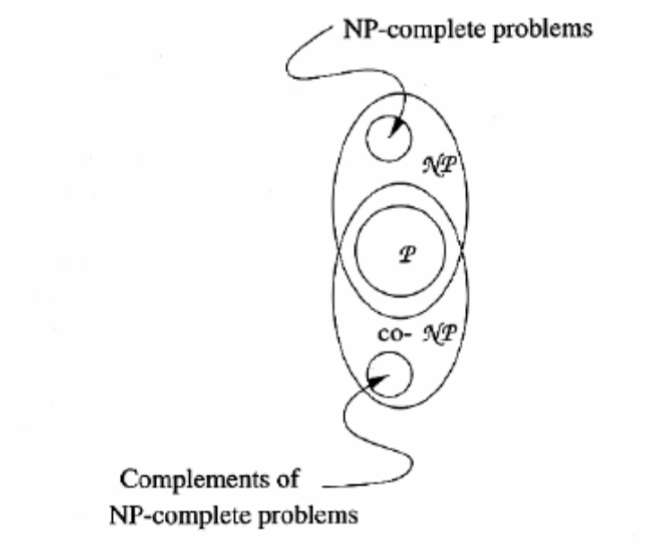

NP-Complete Problems and Co-NP
Let us assume that P= NP. It is still possible that the situation regarding co-NP is not exactly as suggested by figure. Because we could have NP and are in NP, and yet not be able to solve them in deterministic polynomial time. However, the fact that we have not been able to find even one NP complete problem whose complement whose complement is in NP is strong evidence that NP= co-NP, as we prove in the next theorem.
Refer the theorem NP=co-NP if and only if there is some NP-complete problem whose complement is in NP.

Write short notes on Problems Solvable in Polynomial Space?(or) (10 Marks)
Describe the problem solving in polynomial space?(or)
Explain polynomial space on Turing machine?(or)Show the relationship of PS and NPS previously defined classes?

Initially, we shall distinguish between the languages accepted by deterministic and nondeterministic TM’s with a polynomial space bound, but we shall soon see that these two classes of languages are the same.
There are complete problems P for polynomial space in the sense that all problems in this class are reducible in polynomial time to P. Thus, if P is in P or in NP, then all languages with polynomial space bounded TM’s are in P or NP respectively. We shall offer one example of such a problem: “quantified Boolean formulas”.

Polynomial-Space Turing Machines
A polynomial-space-bounded Turing machine is suggested. There is some polynomial p(n) such that when given input w of length n, the TM never visits more than p(n) cells of its tape.
Define the class of languages PS to include all and only the languages that are L(m) for some polynomial-space-bounded, deterministic Turing machine M. Also, define the class NPS(nondeterministic polynomial space) to consist of those languages that are L(M) for some nondeterministic, polynomial-space-bounded TM M. Evidently PS, NPS, since every deterministic TM is technically nondeterministic also. However, we shall prove the surprising result that PS=NPS

Relationship of PS and NPS to Previously Defined Classes

To start, the relationships P ⊆ PS and NP ⊆ NPS should be obvious. The reason is that if a TM makes only a polynomial number of moves then it uses no more than a polynomial number of cells: in particular, it cannot visit more cells than one plus the number of moves it makes. Once we prove PS-NPS, we shall see that in fact the three classes form a chain of containment: P ⊆ NP ⊆ PS.

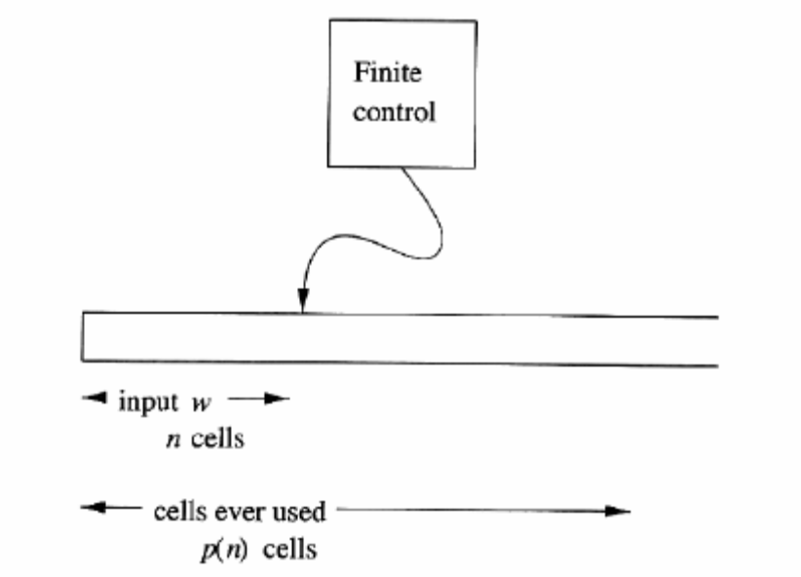
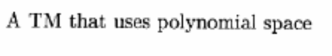
An essential property of polynomial-space-bounded TM’s is that they can make only an exponential number of moves before they must repeat an ID. We need this fact to prove other interesting facts about PS, and also to show that PS contains only recursive languages; i.e., languages with algorithms. Note that there is nothing in the definition of PS or NPS that requires the TM to halt. It is possible that the TM cycles forever, without leaving a polynomial sized region of its tape.

Deterministic and Nondeterministic Polynomial Space

Since the comparison between P and NP seems so difficult, it is surprising that the same comparison between PS and NPS is easy: they are the same classes of languages. The proof involves simulating a nondeterministic TM that has a polynomial space bound p(n) by a deterministic TM with polynomial space bound O(p²(n)).

The heart of the proof is a deterministic, recursive test for whether a NTM N can move from ID I to ID J in at most m moves. A DTM D systematically tries all middle ID’s K to check whether I can become K in m/2 moves, and function reach (I,J,m) that decides if I J by at most m moves.

Think of the tape of D as a stack, where the arguments of the recursive calls to reach are placed. That is, in one stack frame D holds [I,J,M]. A sketch of the algorithm executed by reach.

BOOLEAN FUNCTION reach(I,J,m)
ID: I,J;INT: m;
BEGIN
IF (m= =1) THEN /* basis */BEGIN
Test if I= = J or I can become J after one move;
RETURN TRUE IF SO, FALSE if not;
END;
ELSE /* inductive part */BEGIN
FOR each possible ID K DO
IF (reach (I,K,m/2) AND reach(K,J,m/2)) THEN
RETURN TRUE;
RETURN FALSE;
END;
END;

It is important to observe that, although reach calls itself twice, it makes and therefore only one of the calls is active at a time. On, until at some point the third argument becomes 1. At that point, reach can apply the basis step, and needs no more recursive calls. It tests if I=J or I-J, returning TRUE if either holds and FALSE if neither does. Figure suggests what the stack of the DTM D looks like when there are as many active calls to reach as possible, given an initial move count of m.

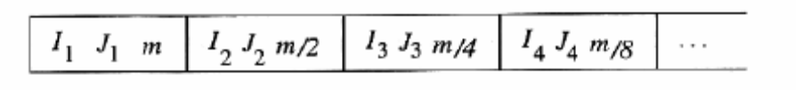

While it may appear that many calls to reach are possible, and the tape of can become very long, we shall show that it cannot become “too long”. That is, if started with a move count of m, there can only be log2 m stack frames on the tape at any one time. Since Theorem assures us that the NTM N cannot make more than c^{p(n)} moves, m does not have to start with a number greater than that. Thus, the number of stack frames is at most. Log₂c^{p(n)} which is O(p(n)). We now have the essentials behind the proof of the following theorem.
Theorem: (Savithc’s Theorem) PS=NPS.

PROOF:
It is obvious that PS NPS since every DTM is technically a NTM as well. Thus, we need only to show that NPS PS; that is if L is accepted by some NTM N with space bound p(n) . for some polynomial p(n) then L is also accepted by some DTM D with polynomial space bound q(n) for some other polynomial q(n). In fact we shall show that q(n) can be chosen to be on the order of the square of p(n).

First, we may assume by Theorem 11.3 that if N accepts, it does so within c^{1+p(n)} steps for some constant c. Given input w of length n, D discovers what N does with input w by repeatedly placing the triple [Io,J,m] on its tape and calling reach with these arguments, where:
- Io is the initial ID of N with input w.
- J is any accepting ID that uses at most p(n) tape cells; the different J’s are enumerated systematically by D, using a scratch tape.
- m=log2 c^{1+p(n)}.

We argued above that there will never be more than log₂m recursive calls that are active at the same time one with third argument m, one with m/2 one with m/4 and so on, down to 1. Thus, there are no more than log₂m stack frames on the stack and log₂ m is O(p(n)).

In binary, it requires = log₂c^{1+p(n)} cells, which is O(p(n)). Thus, the entire stack frame, consisting of two ID’s and an integer, takes O(p(n)) space.

Since D can have O (p(n)) stack frames at most, the total amount of space used is o(p²(n)). This amount of space is a polynomial if p(n) is polynomial. So we conclude that L has a DTM that is polynomial-space bounded.

In summary, we can extend what we know about complexity classes to include the polynomial-space classes. The complete diagram is shown in fig.

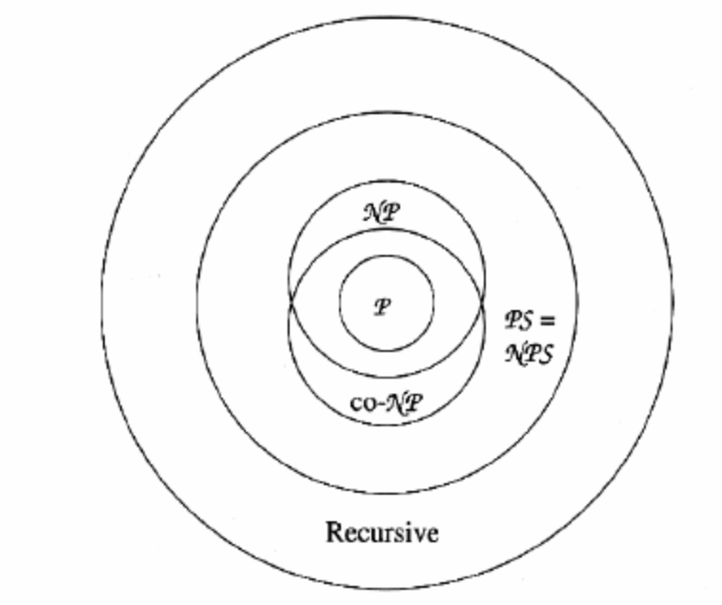

 End of Unit -5 

